
Submitted by: Aansa Mazhar
SAP ID : 70194163
Department: CS & IT department
Program: BS – Cyber Security
Section: 2A
Subject: Programming Fundamentals
Document: LAB manual
Submitted To: Prof. Danial Asif.

CONTENT PAGE
Contents:
LAB 1 | DataTypes, Variable declaration, and Initialization, Single/Multiline Comment, cout and cin statements.
LAB 2 | Using if, if-else, switch.
LAB 3 | Loops (for, while, do-while)
LAB 4 | Nested statements (nested if-else, nested loops)
LAB 5 | Arrays(1D)
LAB 6 | Array (2D)
LAB 7 | Flowgorithm
LAB 8 | C – Strings
MID – TERM EXAMINATION
LAB 9 | Functions
LAB 10
LAB 11
LAB 12
LAB 13
LAB 14
LAB 15
LAB 16

LAB 1
DataTypes, Variable declaration, and Initialization, Single/Multiline Comment, cout and cin statements.

Write a program that stores your own details in variables .i.e; your name , your age, your CGPA, your semester ,and your section.
#include <iostream>
#include <string>
using namespace std;

int main() {
string name = "Aansa MAZHAR";
int age = 20;
float cgpa = 4.0;
int semester = 2;
string section = "A";

cout << "Name: " << name << endl;
cout << "Age: " << age << endl;
cout << "CGPA: " << cgpa << endl;
cout << "Semester: " << semester << endl;
cout << "Section: " << section << endl;

return 0;
}
Output:
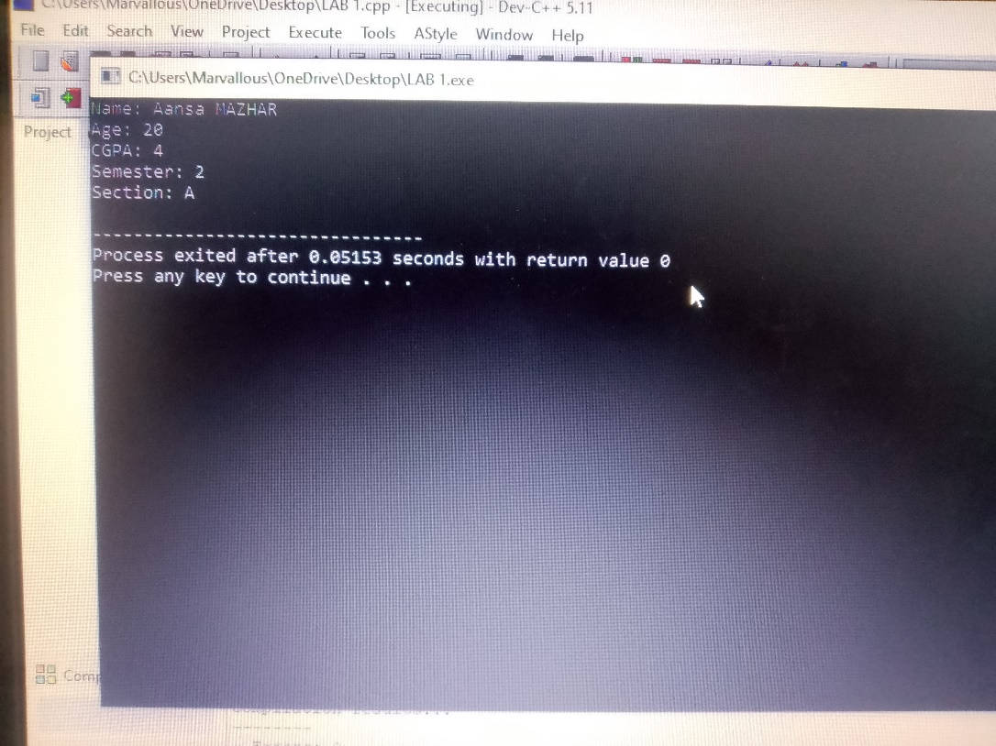
Write a program that stores your own details in variables . i.e; your weight and age.
#include <iostream>
using namespace std;

int main() {
int age = 20;
float height = 5.8;

cout << "Age: " << age << " years" << endl;
cout << "Height: " << height << " feet" << endl;

return 0;
}
Output:
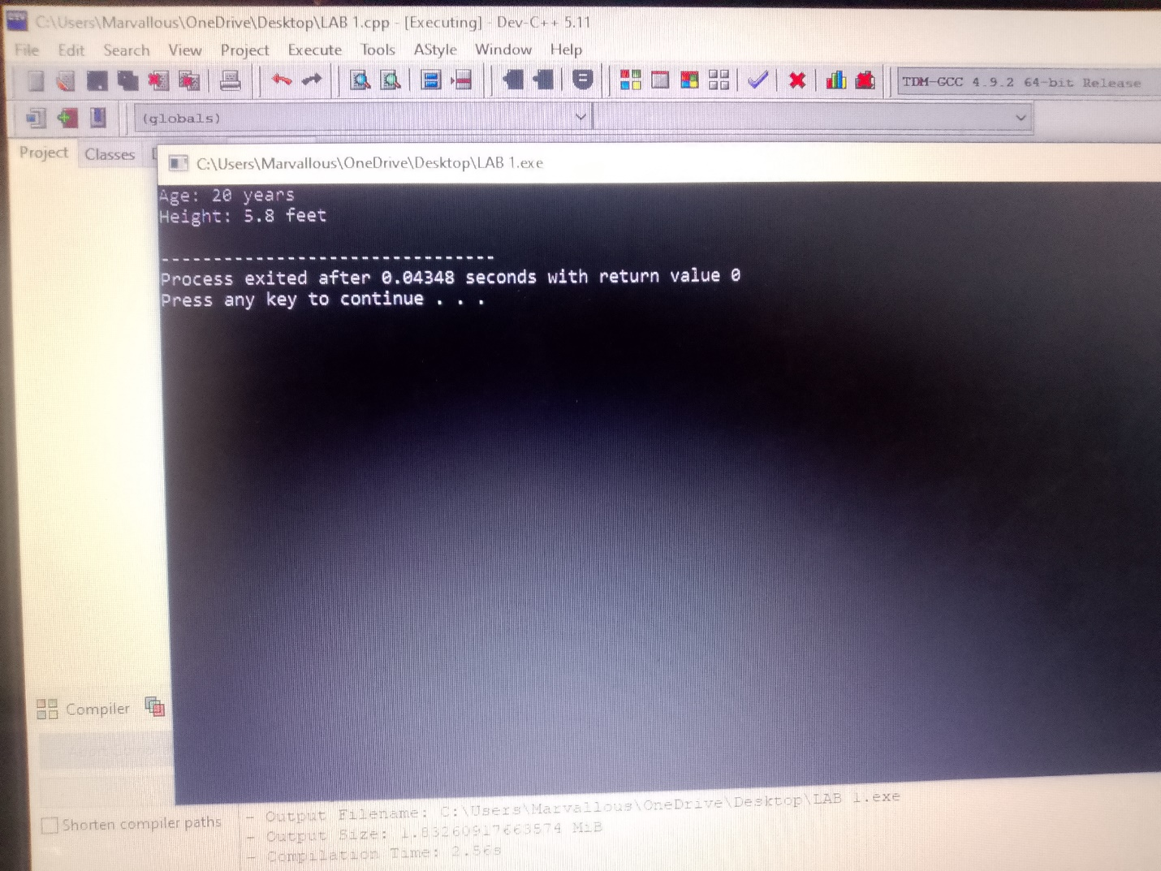
Write a program that asks you to enter your details one by one .
#include <iostream>
#include <string>
using namespace std;

int main() {
string name, section;
int age, semester;
float cgpa;

cout << "Enter your name: ";
cin >> name;

cout << "Enter your age: ";
cin >> age;

cout << "Enter your CGPA: ";
cin >> cgpa;

cout << "Enter your semester: ";
cin >> semester;

cout << "Enter your section: ";
cin >> section;

cout << "\nMy name is " << name << ". I am " << age << " years old, my CGPA is " << cgpa << ", I am studying in Semester " << semester << ", Section " << section << ".";

return 0;
}
Output:
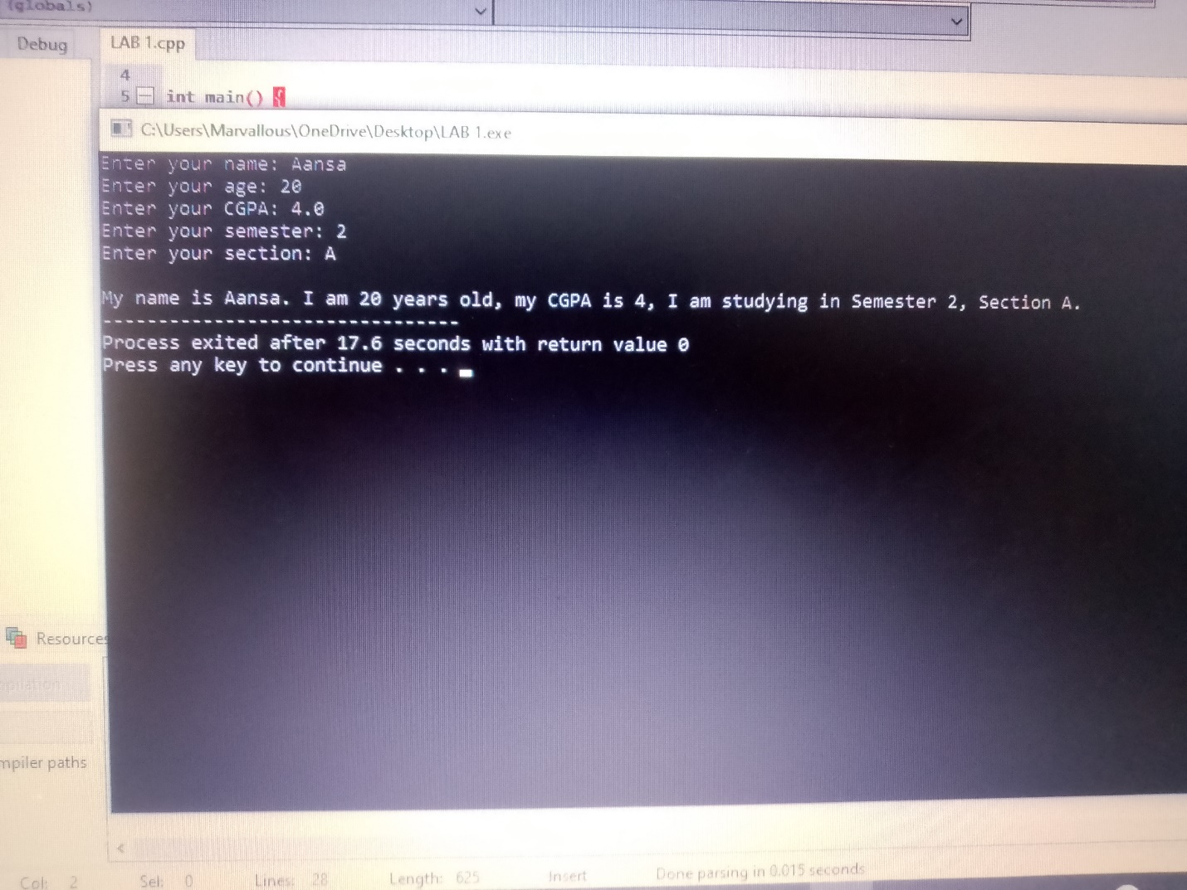

LAB 02
Using if, if-else, switch
Write a program using if-else statement that will ask the user to enter his age and the compiler will tell that are you eligible or ineligible to cast a vote.
Condition: age>= 18 : eligible Otherwise ineligible .
#include <iostream>
using namespace std;

int main() {
int age;
cout << "Enter your age";
cin >> age;

if (age >= 18) {
cout << "eligible";
} else {
cout << "Not eligible";
}

return 0;
}
Output :
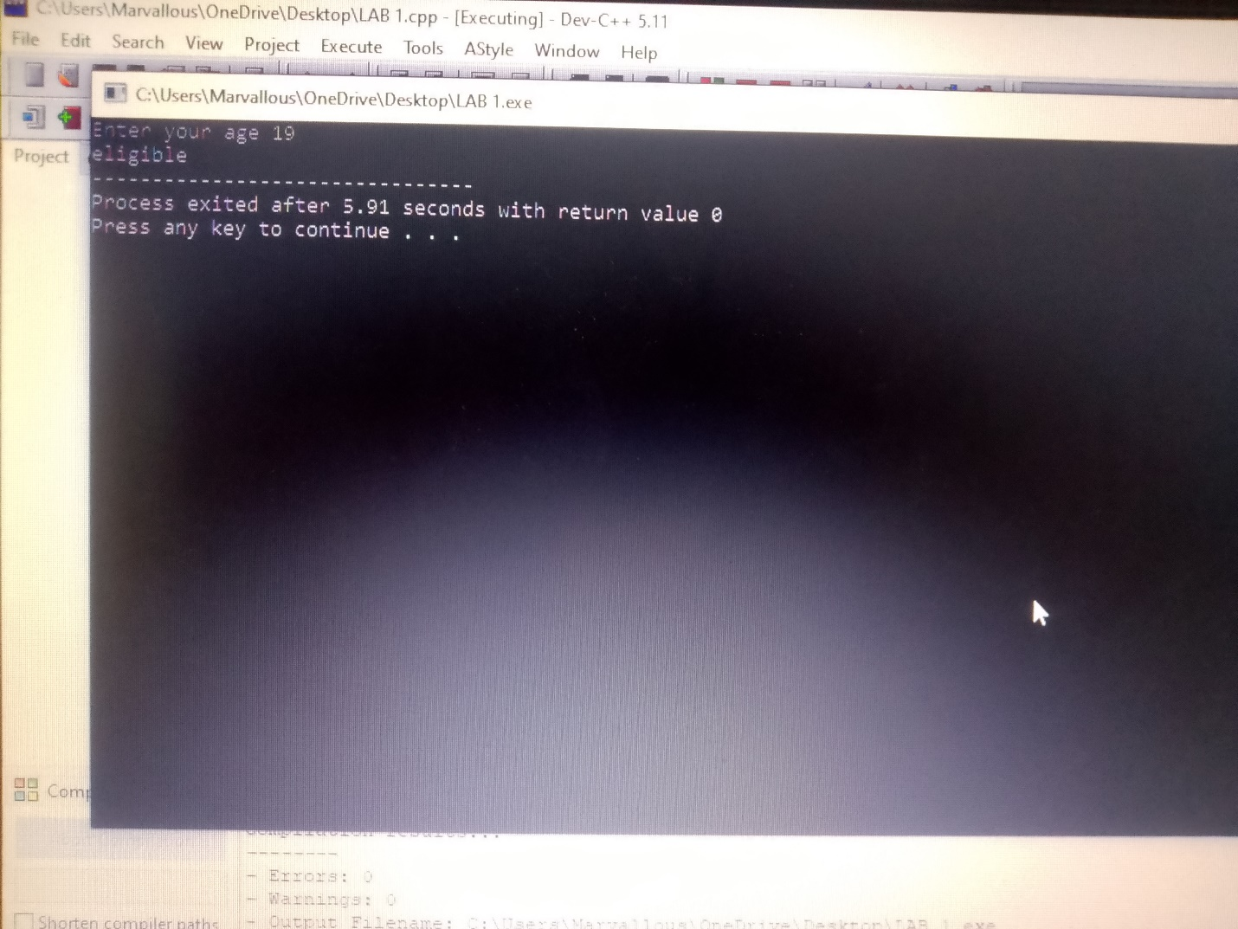
Write a program using if -else, that will ask the user for the month number and tell the name of corresponding season.
#include <iostream>
using namespace std;

int main() {
int month;
cout << "Enter month number (1-12): ";
cin >> month;

if (month >= 3 && month <= 5) {
cout << "Season is Spring";
}
else if (month >= 6 && month <= 8) {
cout << "Season is Summer";
}
else if (month >= 9 && month <= 11) {
cout << "Season is Autumn";
}
else if (month == 12 || (month >= 1 && month <= 2)) {
cout << "Season is Winter";
}
else {
cout << "Invalid month number";
}

return 0;
}
Output:
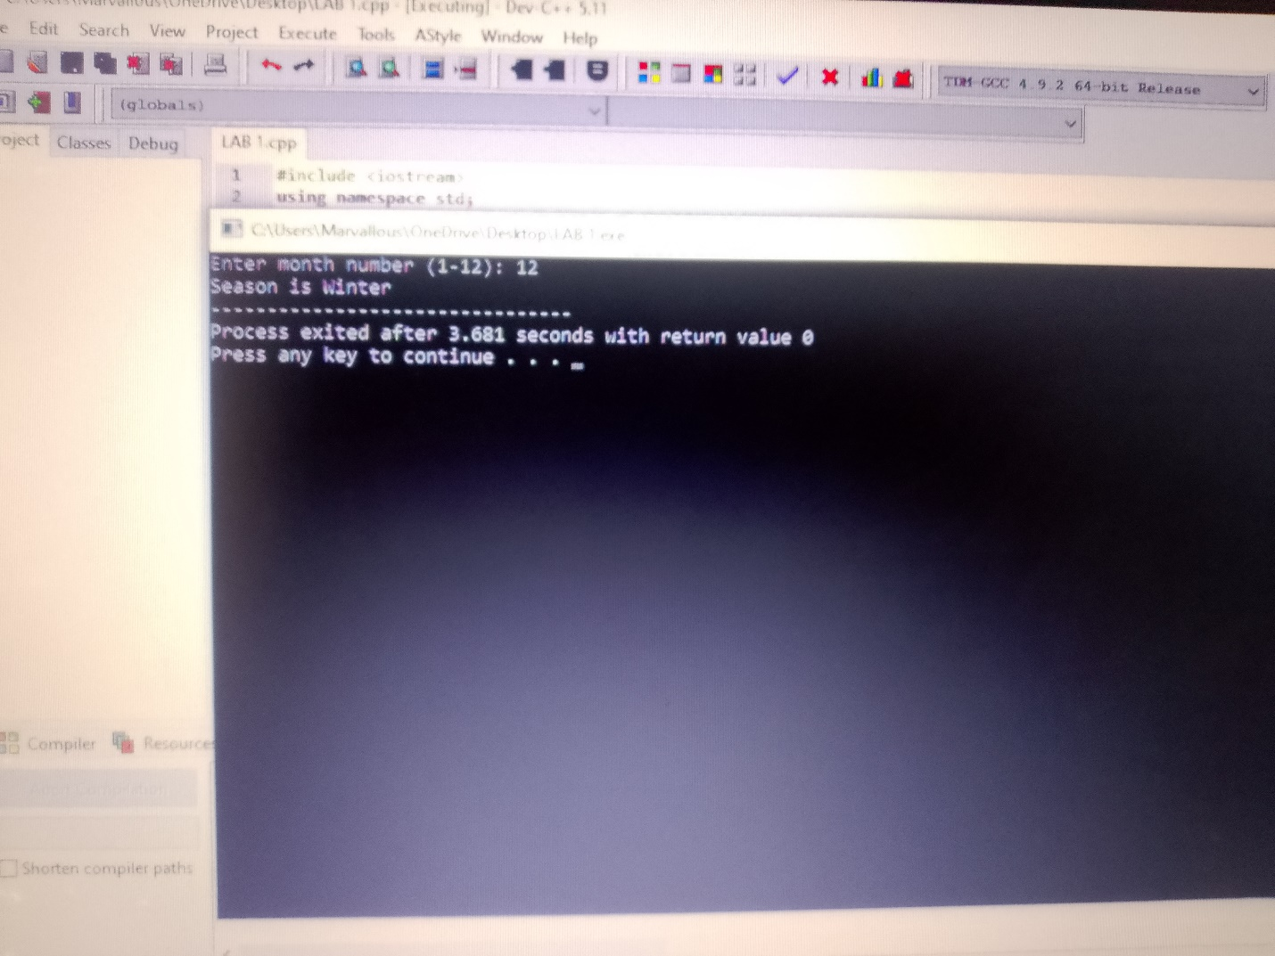
Write a C++ program using switch statement that asks the user to enter a day number (1 to 7) and displays the name of the corresponding day.
#include <iostream>
using namespace std;

int main() {
int day;
cout << "Enter day number (1-7): ";
cin >> day;

switch (day) {
case 1:
cout << "Monday";
break;
case 2:
cout << "Tuesday";
break;
case 3:
cout << "Wednesday";
break;
case 4:
cout << "Thursday";
break;
case 5:
cout << "Friday";
break;
case 6:
cout << "Saturday";
break;
case 7:
cout << "Sunday";
break;
default:
cout << "Invalid day number";
}

return 0;
}

Output:
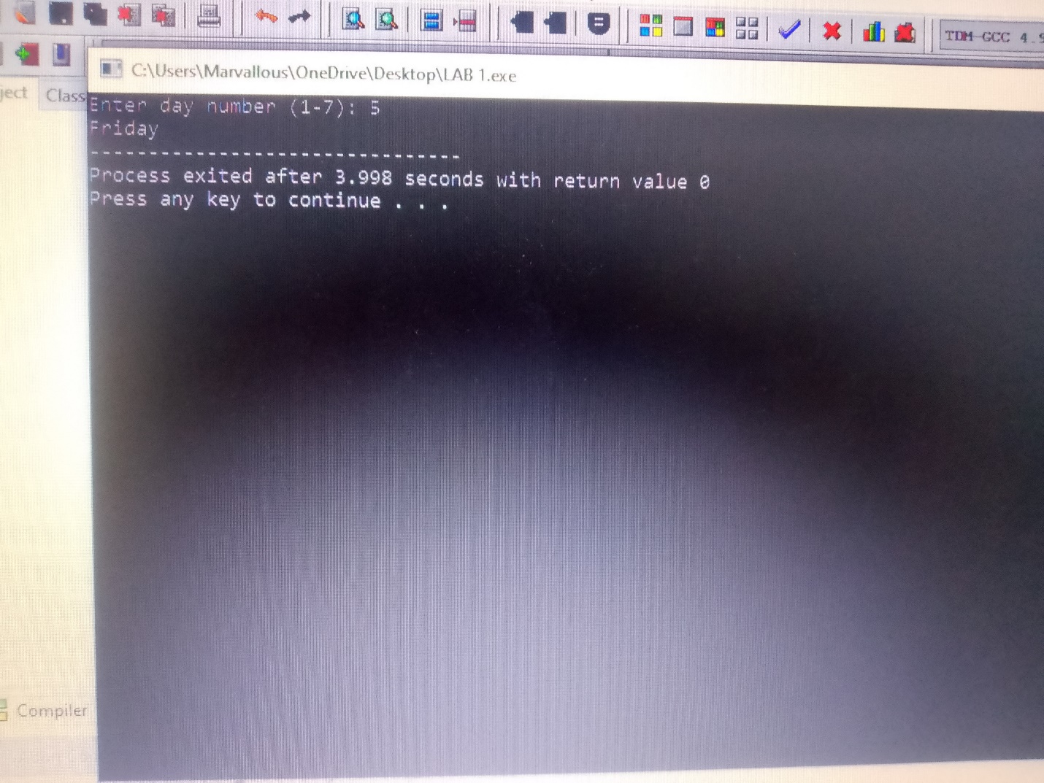

LAB 03
Loops (for, while, do-while)
Write a program using for loop to print the first 10 non negative integers.
#include <iostream>
using namespace std;

int main() {

for (int i = 0; i < 10; i++) {
cout << i << endl;
}

return 0;
}
Output:
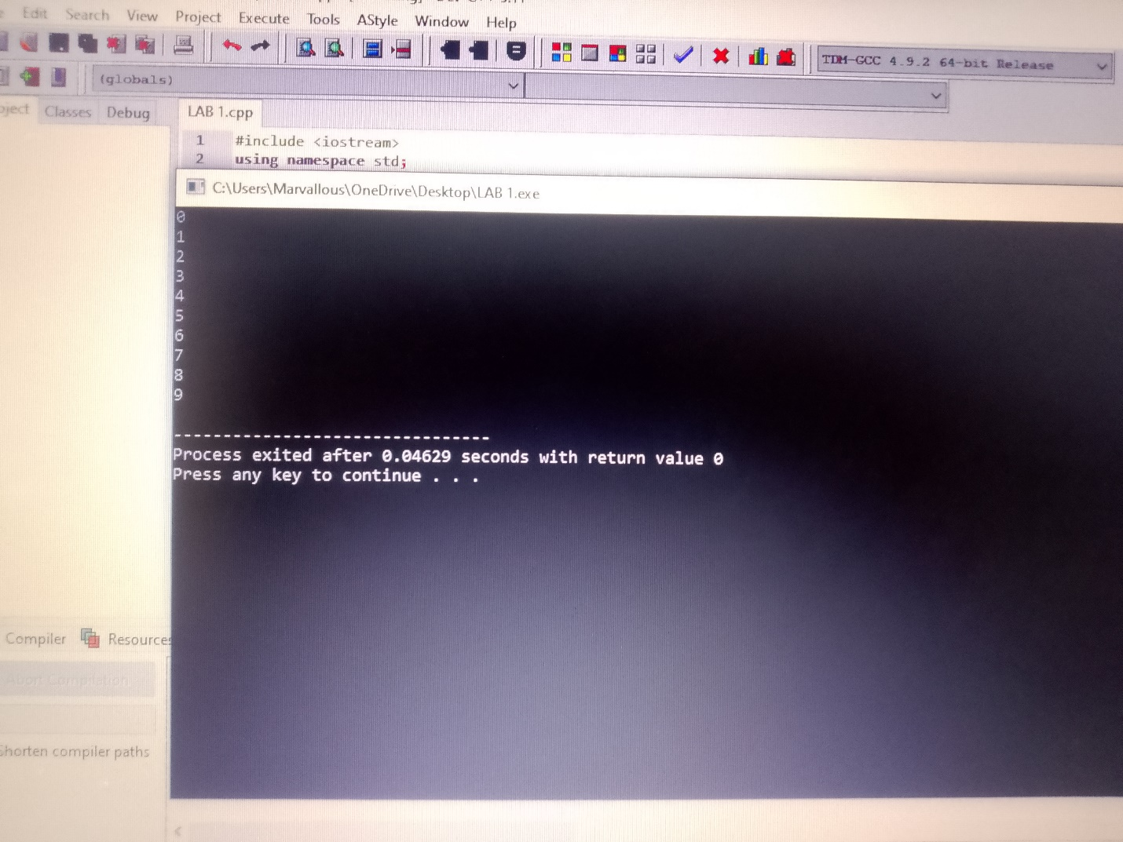
Write a program to print 10 stars in a triangle shape using while loop.
#include <iostream>
using namespace std;

int main() {
int i = 1;

while (i <= 4) {
int j = 1;
while (j <= i) {
cout << "* ";
j++;
}
cout << endl;
i++;
}

return 0;
}
Output:
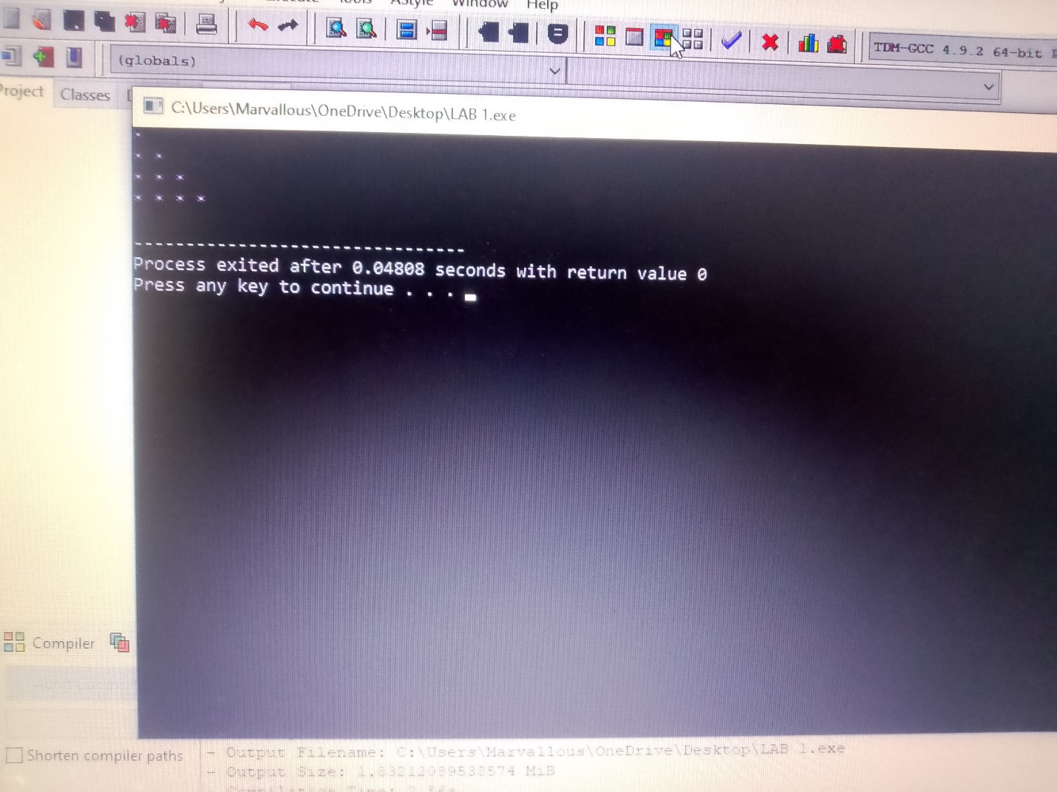
Write a program using do-while loop to print numbers from 0-20with the gap of 5 numbers .
#include <iostream>
using namespace std;

int main() {
int i = 0;

do {
cout << i << " ";
i = i + 5;
}
while (i <= 20);

return 0;
}
Output:
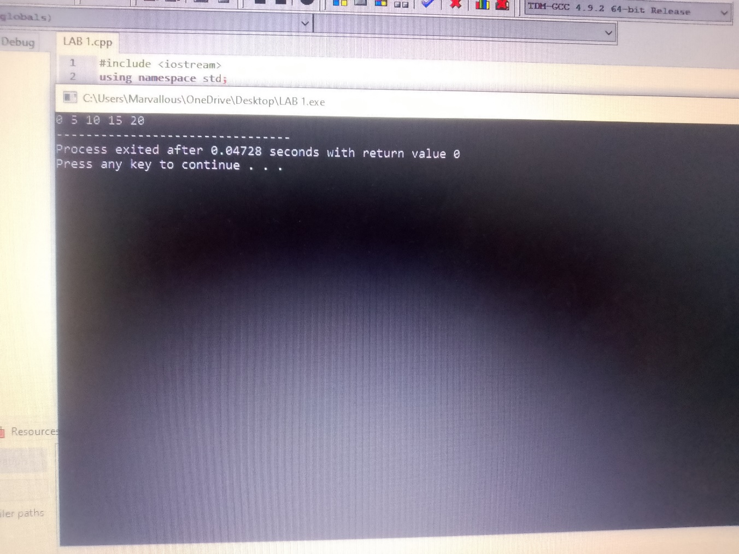
LAB 04
Nested statements (nested if-else, nested loops)
Question: Employee Salary, Bonus and Misconduct SystemA company has 10 employees. Write a C++ program that asks for the salary, performance grade, and misconduct status of each employee.
The bonus is calculated as follows:
_ Grade A -> 30% bonus
_ Grade B -> 20% bonus
_ Grade C -> 10% bonus
_ Grade D -> No bonus
If an employee has committed misconduct, an additional 10% of the basic salary is deducted.
The program should calculate and display:
_ Basic salary
_ Bonus
_ Misconduct deduction
_ Final salary
Use loop and If-else statements
#include <iostream>
using namespace std;

int main() {
float basicSalary, bonus = 0, deduction = 0, finalSalary;
char grade;
char misconduct;

for (int i = 1; i <= 10; i++) {
cout << "\n--- Employee " << i << " ---" << endl;
cout << "Enter basic salary: ";
cin >> basicSalary;

cout << "Enter performance grade (A,B,C,D): ";
cin >> grade;

cout << "Any misconduct? (Y/N): ";
cin >> misconduct;

// Calculate Bonus using if-else
if (grade == 'A' || grade == 'a') {
bonus = basicSalary * 0.30;
} else if (grade == 'B' || grade == 'b') {
bonus = basicSalary * 0.20;
} else if (grade == 'C' || grade == 'c') {
bonus = basicSalary * 0.10;
} else {
bonus = 0; // Grade D
}

// Calculate Misconduct Deduction using if-else
if (misconduct == 'Y' || misconduct == 'y') {
deduction = basicSalary * 0.10;
} else {
deduction = 0;
}

finalSalary = basicSalary + bonus - deduction;

cout << "\nResult for Employee " << i << ":" << endl;
cout << "Basic Salary: " << basicSalary << endl;
cout << "Bonus: " << bonus << endl;
cout << "Misconduct Deduction: " << deduction << endl;
cout << "Final Salary: " << finalSalary << endl;
}

return 0;
}
Output:
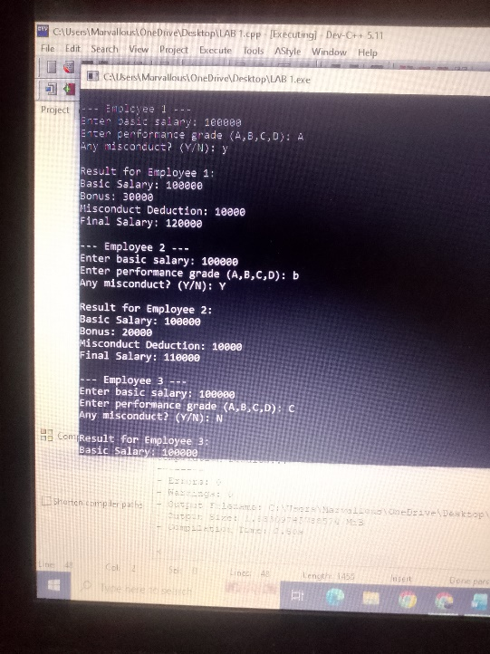
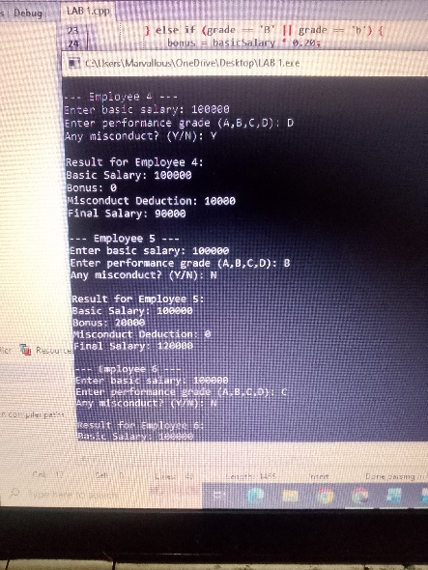
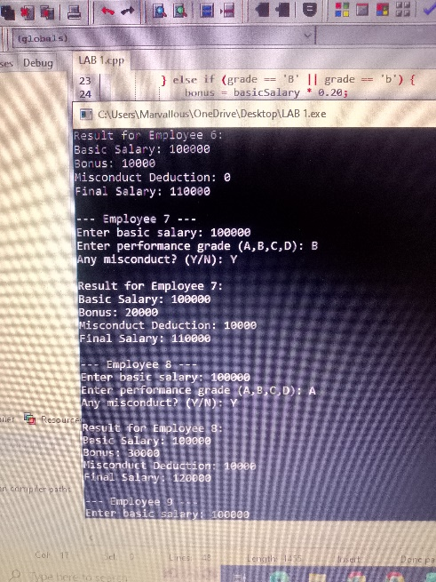
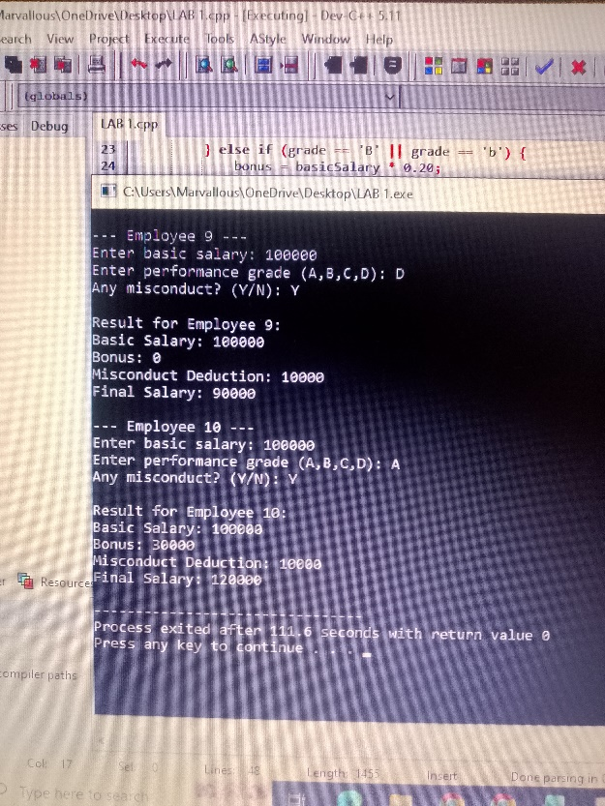
Develop a C++ program for a university fee management system. The program should repeatedly accept the fee details of students until the user chooses to stop. For each student, input the student's ID, name, semester, and tuition fee. Apply a scholarship according to these rules:
_ Semester 1-2: 10% scholarship.
_ Semester 3-6: 5% scholarship.
_ Other semesters: no scholarship.
_ If the original fee is greater than Rs. 100,000, provide an additional 2% discount.Display the original fee, discount, and final fee for every student. At the end, display the total collected fee and the number of students processed.
#include <iostream>
#include <string>
using namespace std;

int main() {
string studentID, studentName;
int semester;
float tuitionFee, discount = 0, finalFee;
float totalCollectedFee = 0;
int studentCount = 0;
char choice;

do {
cout << "Enter Student Details" << endl;
cout << "Enter Student ID: ";
cin >> studentID;
cin.ignore();
cout << "Enter Student Name: ";
getline(cin, studentName);
cout << "Enter Semester: ";
cin >> semester;
cout << "Enter Tuition Fee: ";
cin >> tuitionFee;

discount = 0;

if (semester >= 1 && semester <= 2) {
discount = tuitionFee * 0.10; // 10%
} else if (semester >= 3 && semester <= 6) {
discount = tuitionFee * 0.05; // 5%
} else {
discount = 0; // No scholarship
}
if (tuitionFee > 100000) {
discount = discount + (tuitionFee * 0.02);
}

finalFee = tuitionFee - discount;
totalCollectedFee += finalFee;
studentCount++;

cout << "\n--- Fee Slip ---" << endl;
cout << "Student ID: " << studentID << endl;
cout << "Student Name: " << studentName << endl;
cout << "Original Fee: Rs. " << tuitionFee << endl;
cout << "Discount / Scholarship: Rs. " << discount << endl;
cout << "Final Fee: Rs. " << finalFee << endl;

cout << "\nDo you want to enter another student? (Y/N): ";
cin >> choice;

} while (choice == 'Y' || choice == 'y');

cout << ” Final Report" << endl;
cout << "Total Students Processed: " << studentCount << endl;
cout << "Total Collected Fee: Rs. " << totalCollectedFee << endl;

return 0;
}
Output:
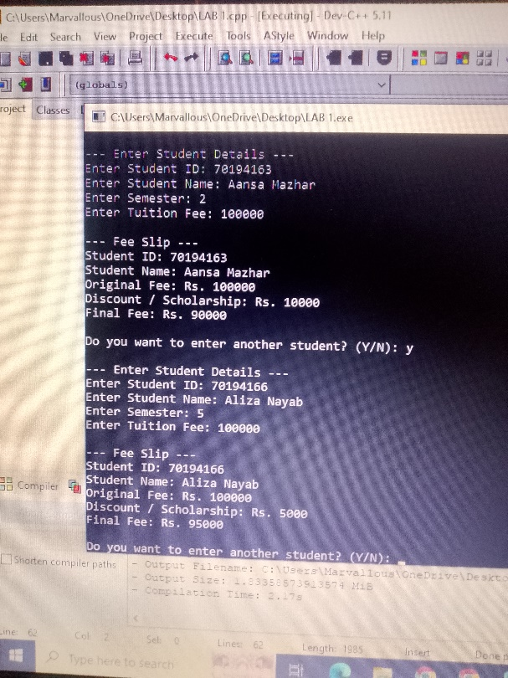
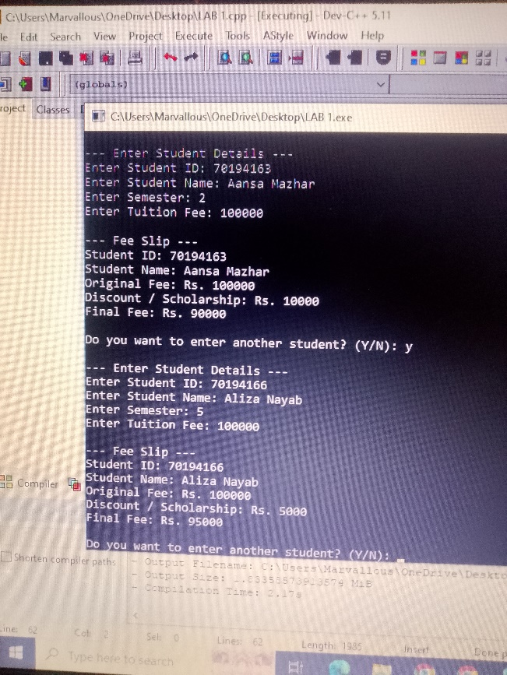
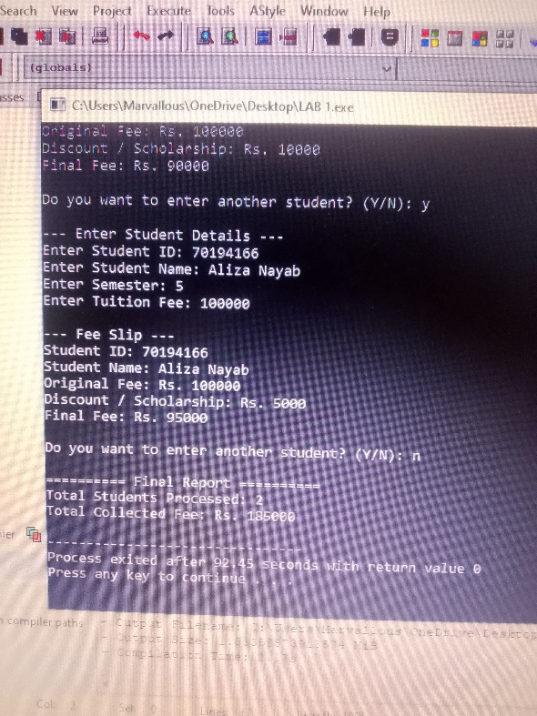

Design a cafeteria program that processes orders for multiple customers. For each customer, display a menu of 5 food items. The customer can order multiple items until they select 0 to finish. Use a do-while loop for each customer's order and a for loop to process 10 customers. Calculate the subtotal, apply a 10% discount for bills above Rs. 3,000, and display the final bill. At the end, show the total sales of the cafeteria
#include <iostream>
using namespace std;

int main() {
float totalSales = 0;

for (int i = 1; i <= 10; i++) {
float subtotal = 0;
int choice;

cout << "Customer " << i << " ---" << endl;
cout << "Menu:" << endl;
cout << "1. Burger - Rs. 500" << endl;
cout << "2. Pizza - Rs. 800" << endl;
cout << "3. Sandwich - Rs. 300" << endl;
cout << "4. Fries - Rs. 200" << endl;
cout << "5. Cold Drink - Rs. 150" << endl;
cout << "0. Finish Order" << endl;

do {
cout << "Enter item number (0 to finish): ";
cin >> choice;

if (choice == 1) subtotal += 500;
else if (choice == 2) subtotal += 800;
else if (choice == 3) subtotal += 300;
else if (choice == 4) subtotal += 200;
else if (choice == 5) subtotal += 150;
else if (choice == 0) break;
else cout << "Invalid choice!" << endl;

} while (choice != 0);

float discount = 0;
if (subtotal > 3000) {
discount = subtotal * 0.10;
}

float finalBill = subtotal - discount;
totalSales += finalBill;

cout << "Subtotal: Rs. " << subtotal << endl;
cout << "Discount: Rs. " << discount << endl;
cout << "Final Bill: Rs. " << finalBill << endl;
}

cout << "\nTotal Sales of Cafeteria: Rs. " << totalSales << endl;

return 0;
}
Output:
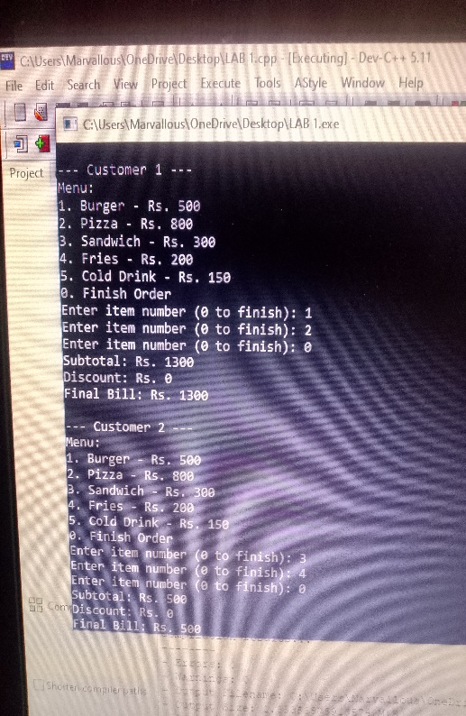
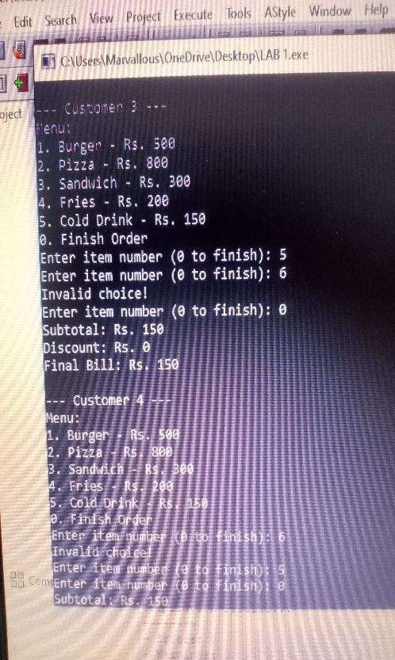
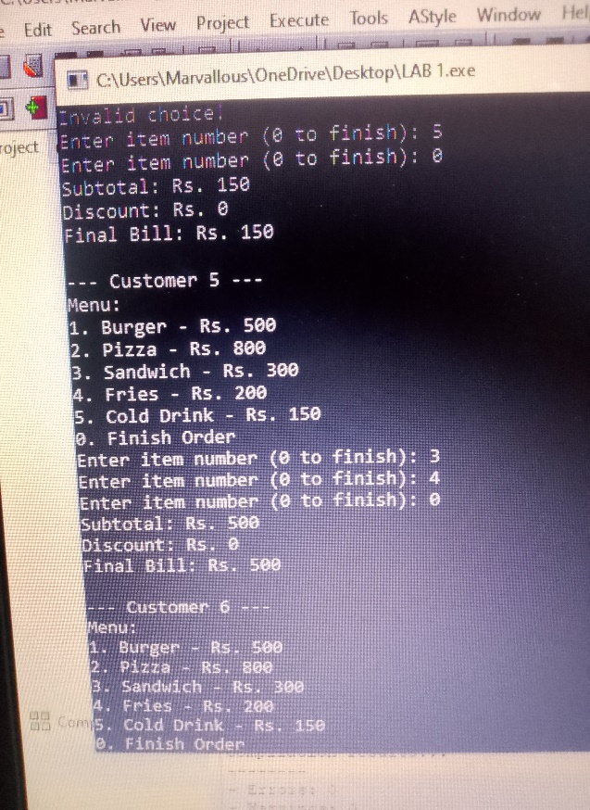
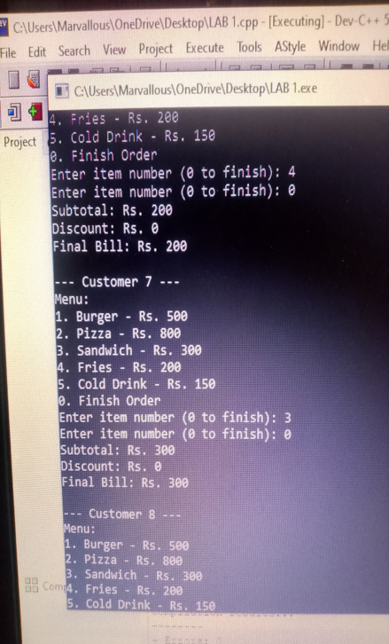

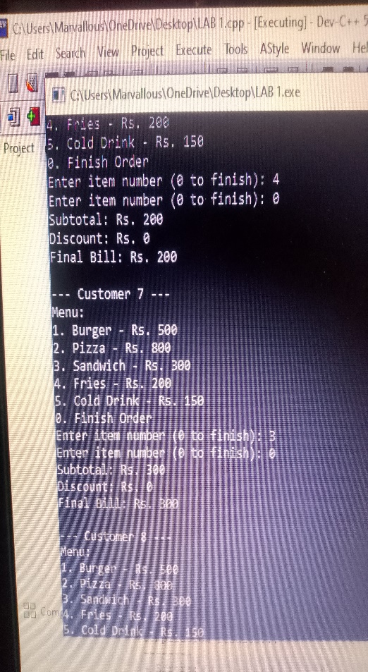
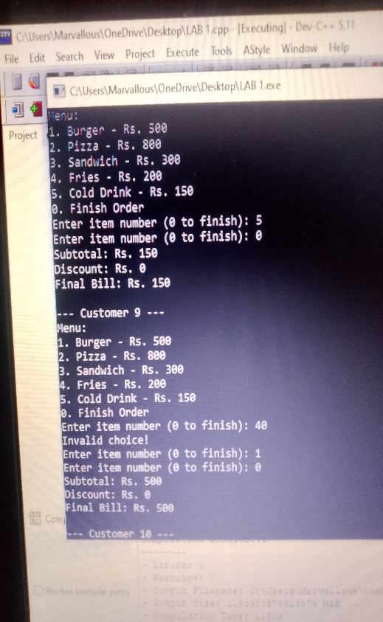
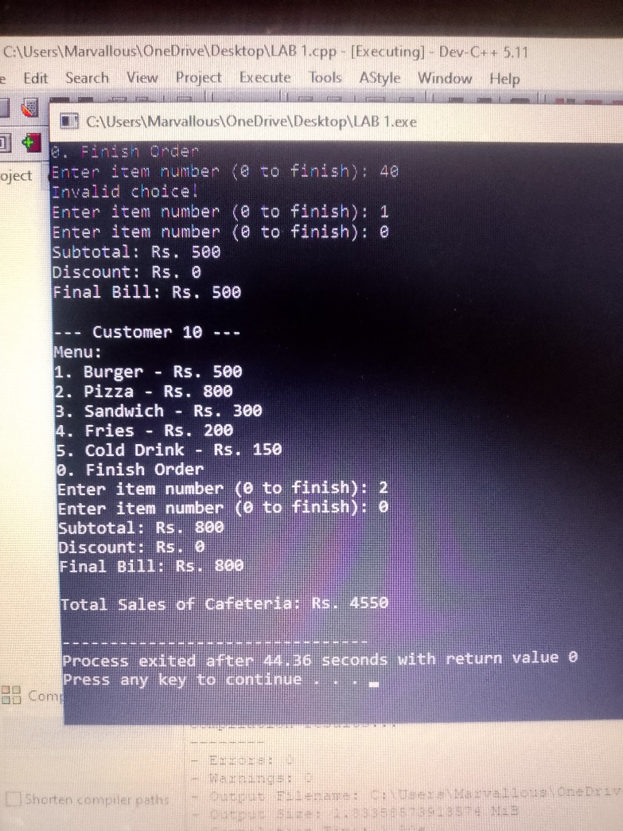
LAB 05
1D array and 2D array
Write a program in which user stores 5 values in 1D array.Then print them .
#include <iostream>
using namespace std;
int main(){
int numbers[5];
cout<<"enter 5 values"<<endl;
for(int i =0; i<5;i++){
cin>> numbers[i];
}
for(int i=0;i<5;i++){
cout<<numbers[i];
}
return 0;
}
Output:
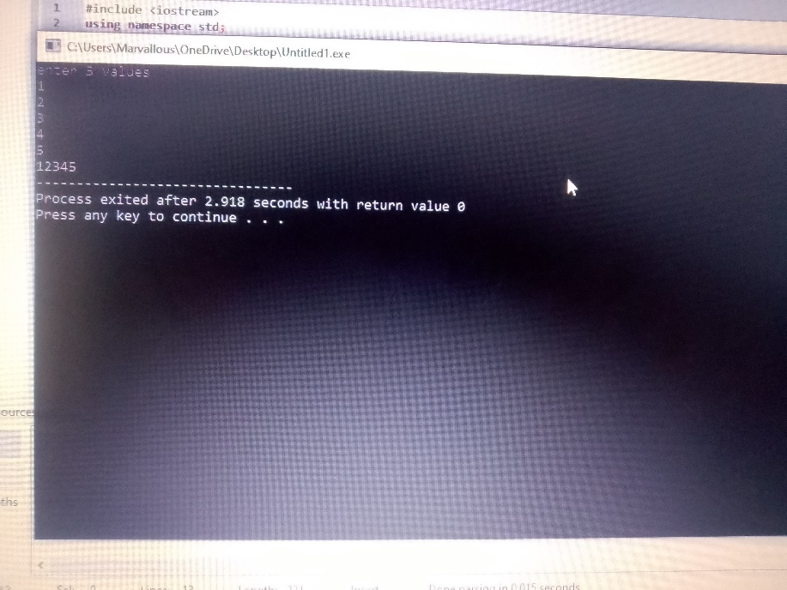
Write a program using 2D aray that takes values from the user and then also print them on screen.
#include <iostream>
using namespace std;
int main(){
int i;
int j;
int numbers[3][2];
cout<<"enter 5 values"<<endl;
for(int i =0; i<3;i++){
for (int j= 0;j<2;j++){
cin>>numbers[i][j];
}
}
for(int i=0;i<3;i++){
for(int j =0;j<2;j++){
cout<<numbers[i][j]<<" ";
}
cout<<endl;
}
return 0;
}
Ouput:
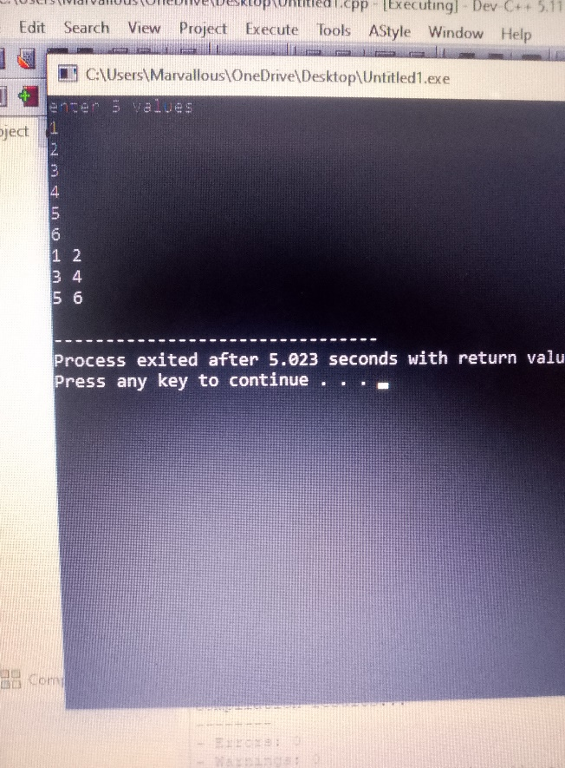

Write a program in cpp using 1D array to find the largest and the smallest number.The user should input the numbers .
#include <iostream>
using namespace std;
int main(){
int numbers[7];
int largest = numbers[0];
int smallest = numbers[0];
for(int i=0; i<7;i++){
cout<<"enter the numbers:"<<endl;
cin>>numbers[i];
}
for(int i=0;i<7;i++){
if(numbers[i]>largest)
if(numbers[i]<smallest)
largest=numbers[i];
smallest=numbers[i];
}
cout<<" the largest number is:"<<largest;
cout<<" the smallest number is:"<<smallest;
return 0;
}
Output:
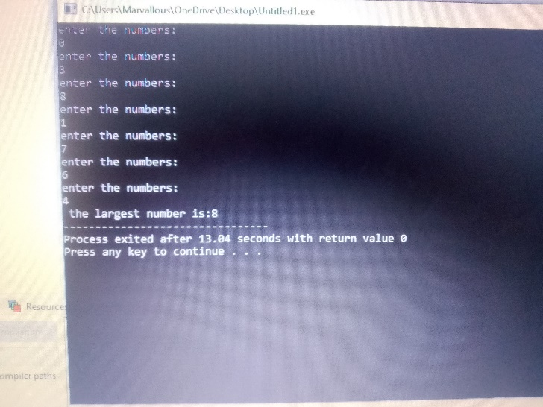
Write a cpp program suing 2D array to the sum of two matrices .
#include <iostream>
using namespace std;
int main(){
int matrixA[3][3],matrixB[3][3],matrixC[3][3];
cout<<" enter elements of matrix A:"<< endl ;
for(int i=0;i<2;i++){
for(int j=0;j<2;j++)
cin >> matrixA[i][j];
}
cout<<" enter elements of matrix B:"<< endl;
for(int i=0;i<2;i++){
for(int j=0;j<2;j++){
cin >> matrixB[i][j];
}
}
for(int i=0;i<2;i++){
for(int j=0;j<2;j++){
matrixC[i][j] = matrixA[i][j] + matrixB[i][j];
}
}
cout<<" the resulant matrix is :"<<endl;
for(int i=0;i<2;i++){
for(int j=0;j<2;j++){
cout<<matrixC[i][j]<< "\t";
}
cout<<endl;
}
cout << endl;
return 0;
}
Output:
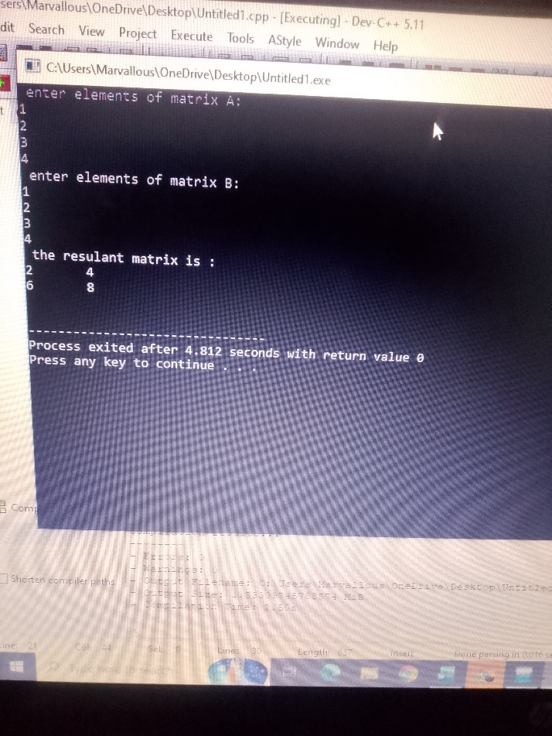

Write a cpp program using 2D array to make a result sheet for students :3, subjects : 4. Find total marks , average and the status of student (pass/fail) .
#include <iostream>
using namespace std;
int main(){
; int total [3];
int marks[3][4];
for(int i=0;i<3;i++){
cout<< " enter the marks of students :"<< i+1 << endl;
for(int j=0;j<4;j++){
cout<<"subjects:"<<j+1;
cin>>marks[i][j];
}
}
cout << " RESULT SHEET:" <<endl;
cout<<"student\ttotal\taverage\tstatus"<<endl;
for(int i =0;i<3;i++){
total[i]=0;
for(int j=0;j<4;j++){
total[i]=total[i]+marks[i][j];
}
float average = total[i]/4.0;
cout<<i+1<<"\t"<<total[i]<<"\t"<<average<"\t";
if( average>40){
cout<<"\t"<<"pass"<<endl;
}
else
cout<<"\t"<<"fail"<<endl;
}
return 0;
}
Output:
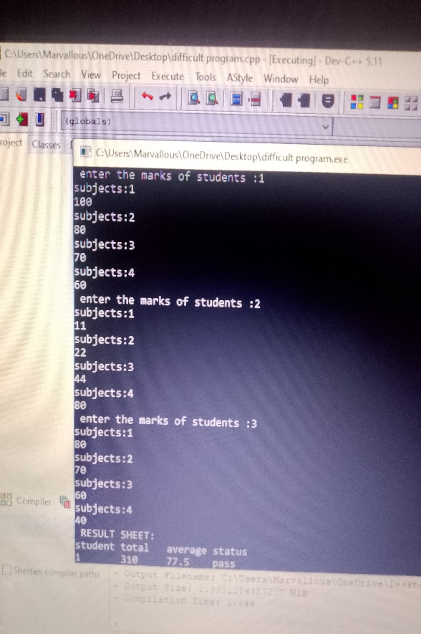
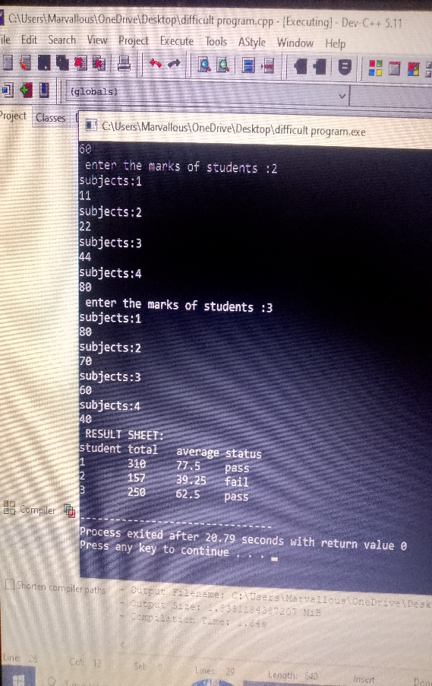

Write a cpp program to write the table of 5,6,7,8,9,10. With multiples upto 20 starting from 3.
#include<iostream>
using namespace std;
int main(){
int answer =1;
int table = 5;
while(table<=10){
cout << "table of:"<<table<< endl;
int multiplier = 3;
while(multiplier <=20){
cout <<table<<"*"<<multiplier<<"="<<table*multiplier<<endl;
int answer = table* multiplier;
multiplier++;
}
cout <<endl;
table++;
}
return 0;

}
Output:
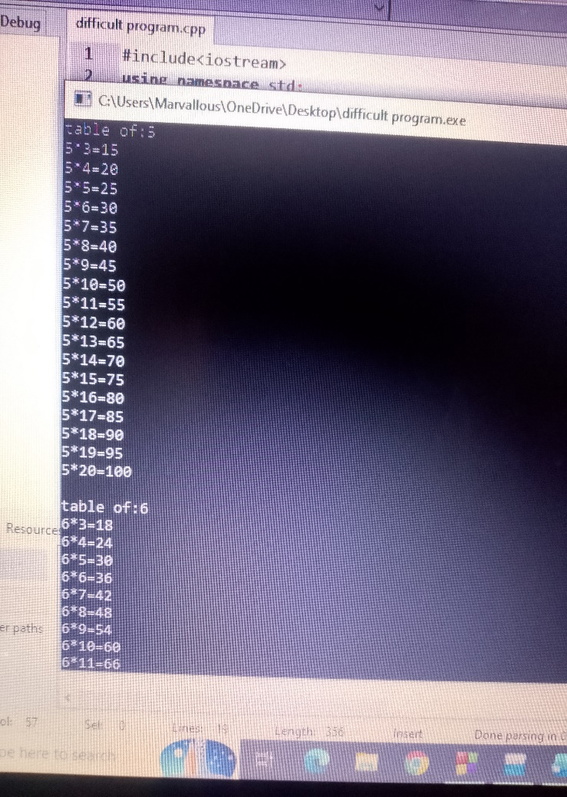
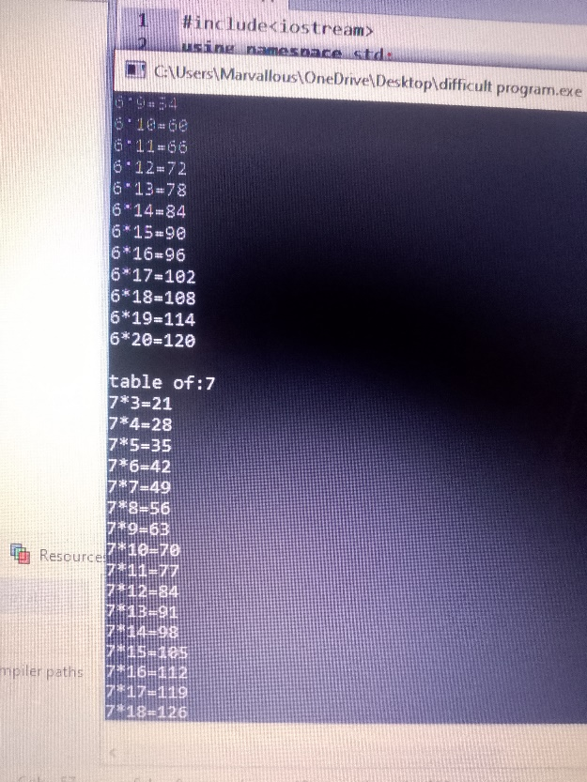
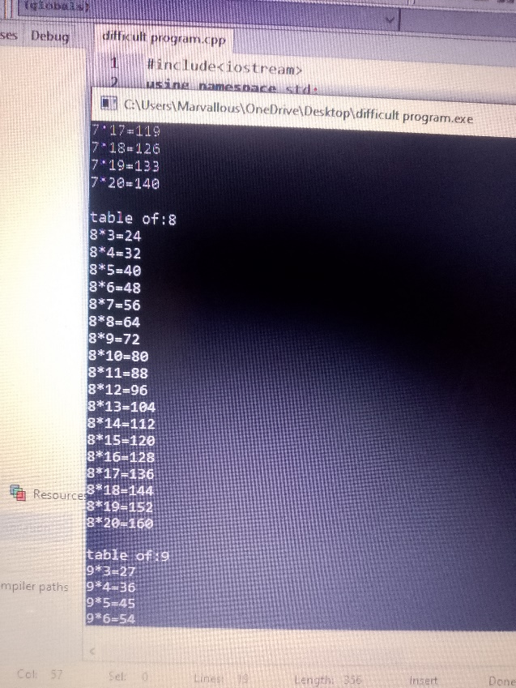
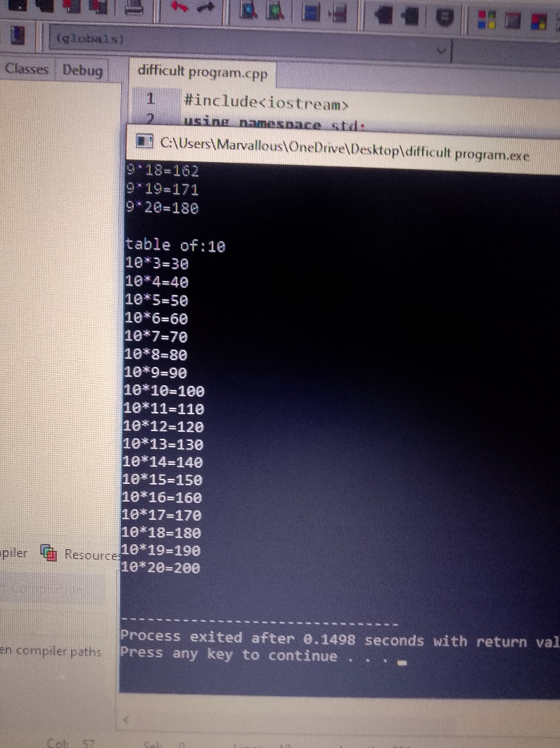
Write a program to make a pyramid of letter X.
#include<iostream>
using namespace std;
int main(){
int j;
int rows= 20;
int i=1;
while(i <= rows){
int space = 1;
while(space <= rows-i){
cout<<" ";
space++;
}
int j =1;
while ( j<=2*i-1){
cout<<"X";
j++;
}
cout<<endl;
i++;
}
return 0;
}
Output:
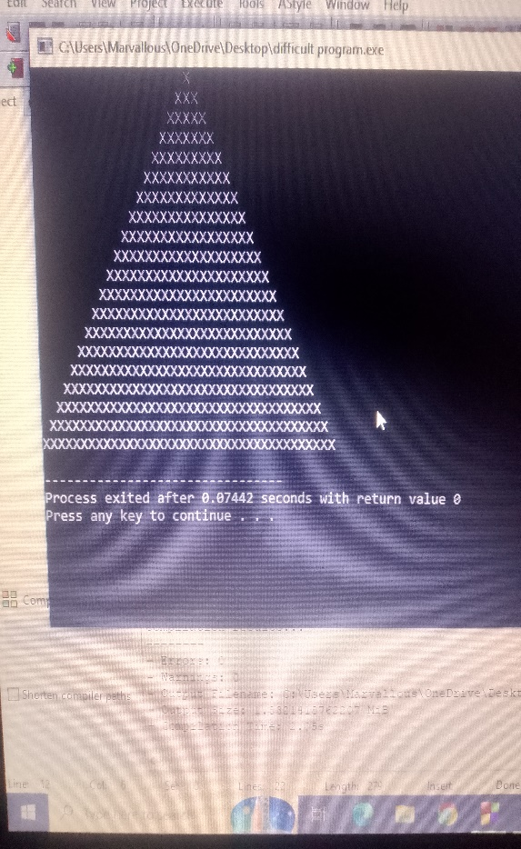

Write a program to make a diamond of stars “*”.
#include<iostream>
using namespace std;
int main(){
int j;
int rows= 10;
int i=1;
while(i <= rows){
int space = 1;
while(space <= rows-i){
cout<<" ";
space++;
}
int j =1;
while ( j<=2*i-1){
cout<<"*";
j++;
}
cout<<endl;
i++;
}
i=rows-1;
while(i >=1){
int space = 1;
while(space <= rows-i){
cout<<" ";
space++;
}
int j =1;
while ( j<=2*i-1){
cout<<"*";
j++;
}
cout<<endl;
i--;
}

return 0;
}
Output:
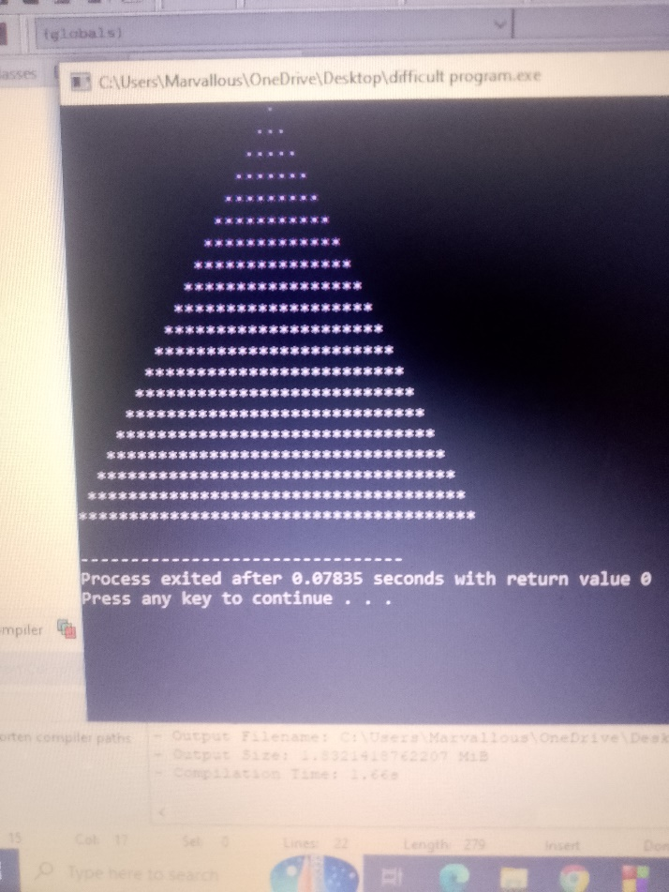

LAB 07
C – STRINGS
#include <iostream>
#include <cstring>
using namespace std;

int main() {
char s1[50] = "Hello";
char s2[50];
strcpy(s2, s1);
cout << "s1 = " << s1 << endl;
cout << "s2 = " << s2;
return 0;
}
Output:
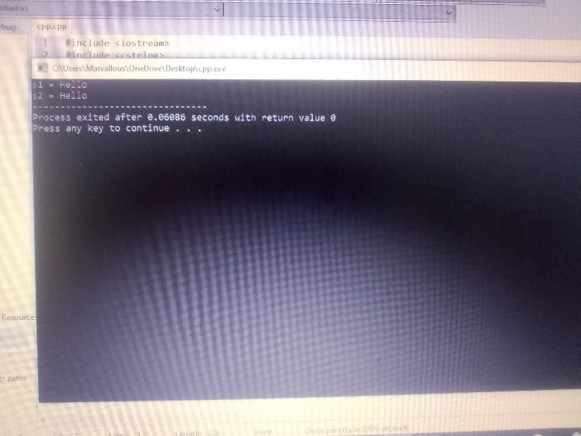
#include <iostream>
#include <cstring>
using namespace std;

int main() {
char s1[50] = "Hello ";
char s2[50] = "World";
strcat(s1, s2);
cout << "Joined string = " << s1;
return 0;
}
Output:
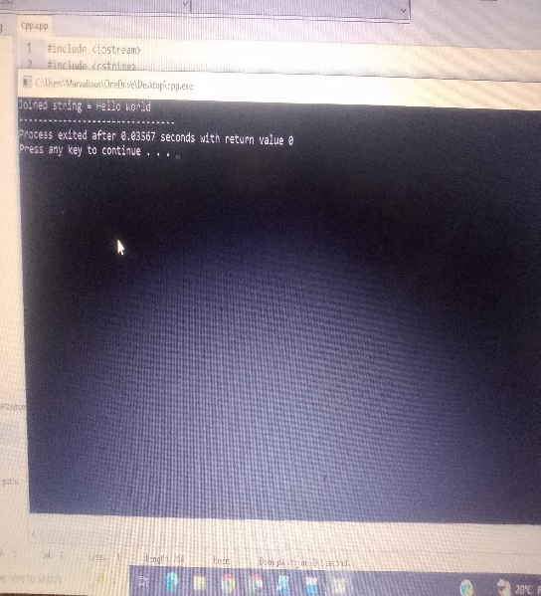
#include <iostream>
#include <cstring>
using namespace std;

int main() {
char s1[50] = "Apple";
char s2[50] = "Apple";
int result = strcmp(s1, s2);
if (result == 0)
cout << "Both strings are equal";
else
cout << "Strings are not equal";
return 0;
}
Output
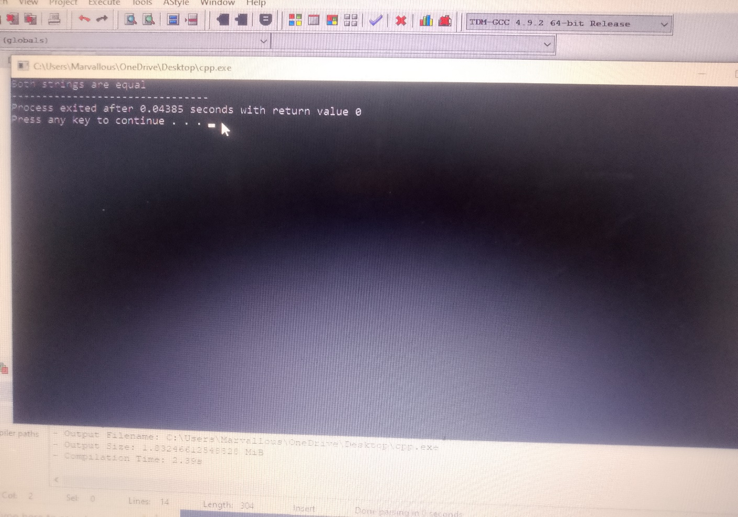
#include <iostream>
#include <cstring>
using namespace std;

int main() {
char s1[50] = "Hello";
cout << "Length = " << strlen(s1);
return 0;
}
Output:
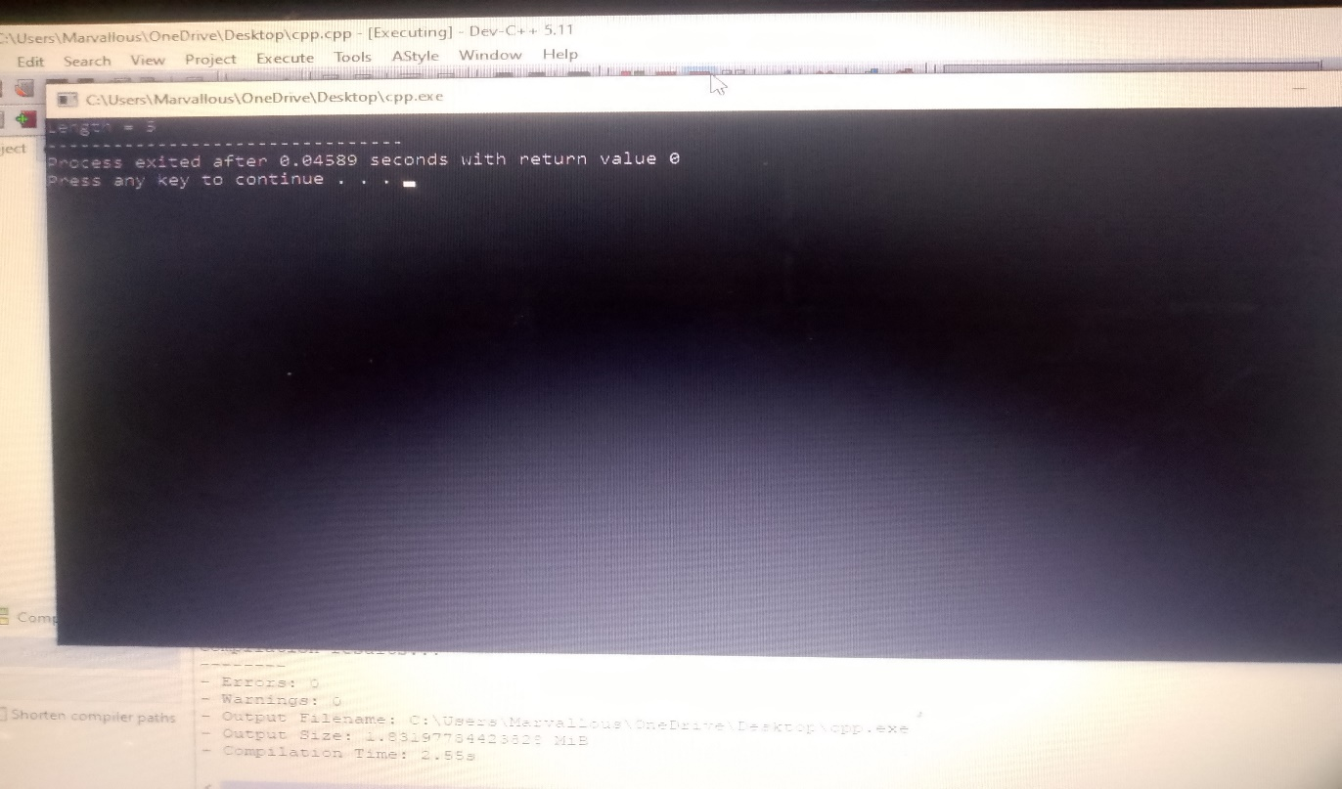
LAB 08
FUNCTIONS

Write a C++ program to make a simple calculator.
1. Make 4 separate functions for 4 operations: Add, Subtract, Multiply, Divide.
2. In `main()`, take 2 numbers and choice from user.
3. Use `switch` statement to call the function according to user's choice.
4. Inside each function, use `if` condition to check that numbers are positive only.
- Condition: `num >= 0`
- If number is negative, print "Please enter positive integer only."
#include <iostream>
using namespace std;

int add(int a, int b) {
if (a >= 0 && b >= 0) {
return a + b;
} else {
cout << "enter positive integer only!" << endl;
return 0;
}
}

int subtract(int a, int b) {
if (a >= 0 && b >= 0) {
return a - b;
} else {
cout << "enter positive integer only!" << endl;
return 0;
}
}

int multiply(int a, int b) {
if (a >= 0 && b >= 0) {
return a * b;
} else {
cout << "enter positive integer only!" << endl;
return 0;
}
}

float divide(int a, int b) {
if (a >= 0 && b >= 0) {
if (b == 0) {
cout << "Cannot divide by 0!" << endl;
return 0;
}
return (float)a / b;
} else {
cout << "Please enter positive integer only!" << endl;
return 0;
}
}

int main() {
int num1, num2, choice;

cout << "Enter first number: ";
cin >> num1;
cout << "Enter second number: ";
cin >> num2;

cout << "Choose Operation:" << endl;
cout << "Add" << endl;
cout << "Subtract" << endl;
cout << "Multiply" << endl;
cout << "Divide" << endl;
cout << "Enter choice (1-4): ";
cin >> choice;

switch (choice) {
case 1:
cout << "Result = " << add(num1, num2) << endl;
break;
case 2:
cout << "Result = " << subtract(num1, num2) << endl;
break;
case 3:
cout << "Result = " << multiply(num1, num2) << endl;
break;
case 4:
cout << "Result = " << divide(num1, num2) << endl;
break;
default:
cout << "Invalid choice!" << endl;
}

return 0;
}
Output:
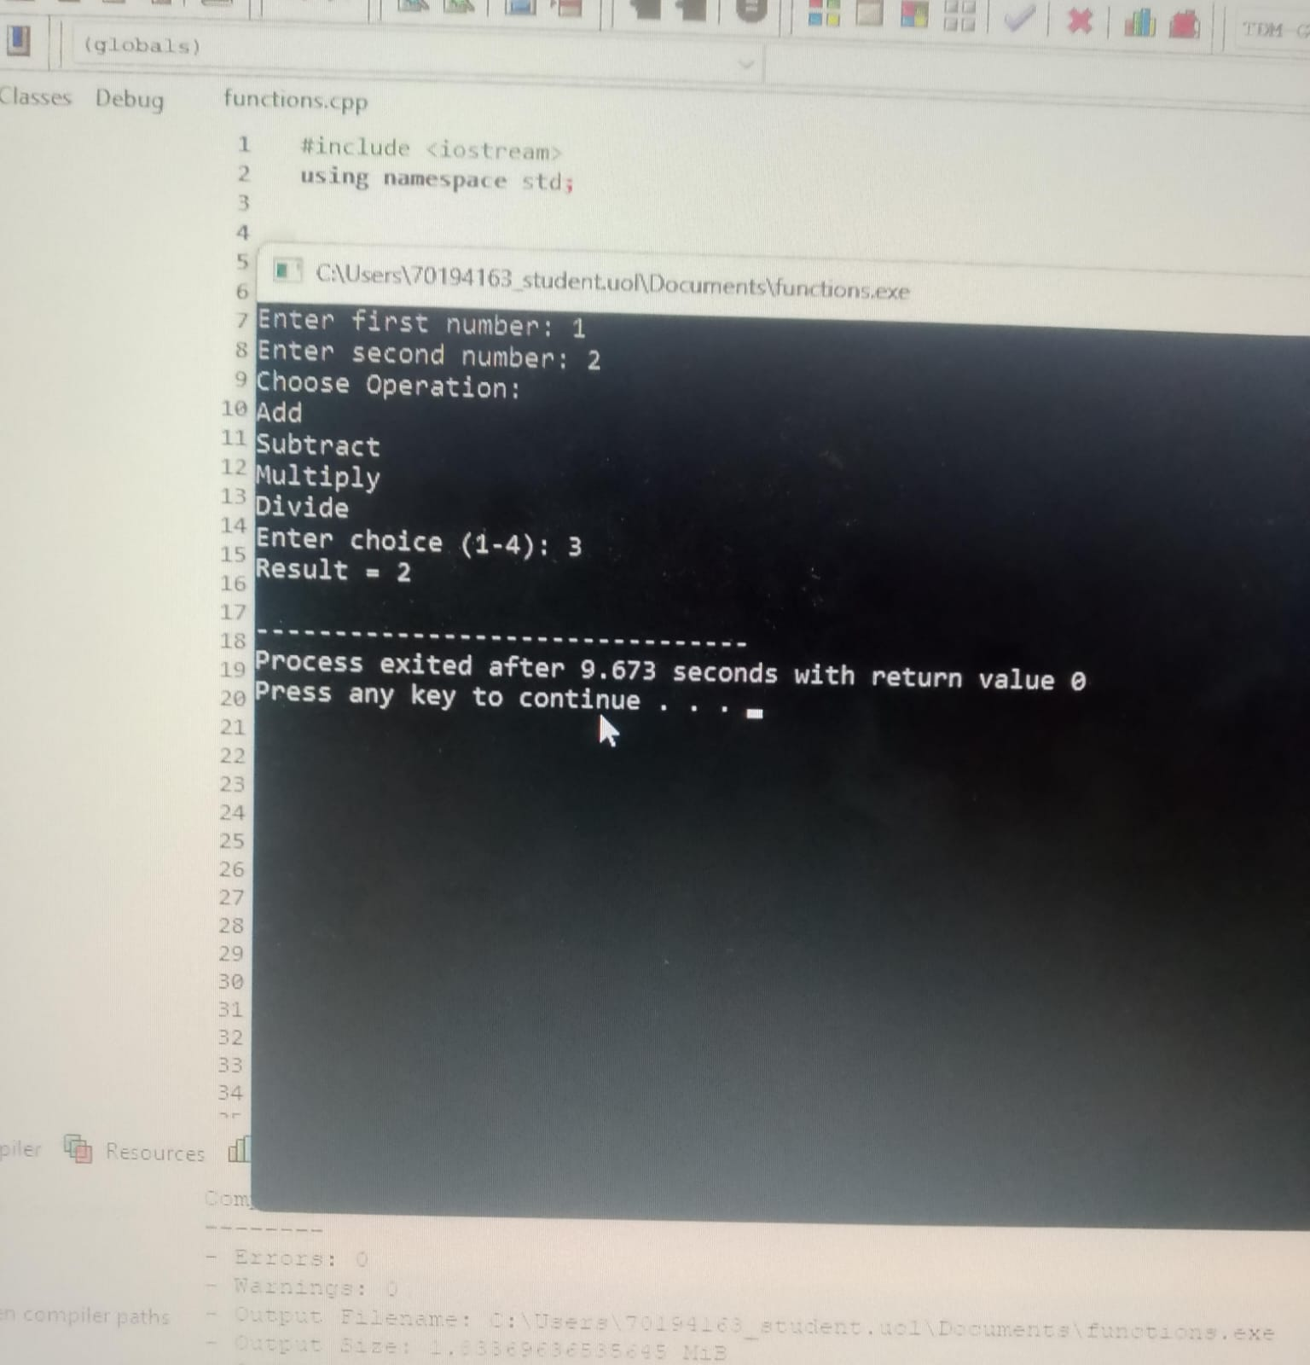
#include <iostream>
using namespace std;
int ADD(int a, int b) {
return a + b;
}

int ADD(int a, int b, int c) {
return a + b + c;
}

float ADD(float x, float y) {
return x * y;
}

float ADD(float x, float y, float z) {
return x * y * z;
}

int main() {
int a, b, c;
float x, y, z;

cout << "Enter 2 integers: ";
cin >> a >> b;
cout << "Result = " << ADD(a, b) << endl;

cout << "Enter 3 integers: ";
cin >> a >> b >> c;
cout << "Result = " << ADD(a, b, c) << endl;

cout << "Enter 2 float numbers: ";
cin >> x >> y;
cout << "Result = " << ADD(x, y) << endl;

cout << "Enter 3 float numbers: ";
cin >> x >> y >> z;
cout << "Result = " << ADD(x, y, z) << endl;

return 0;
}
Output:
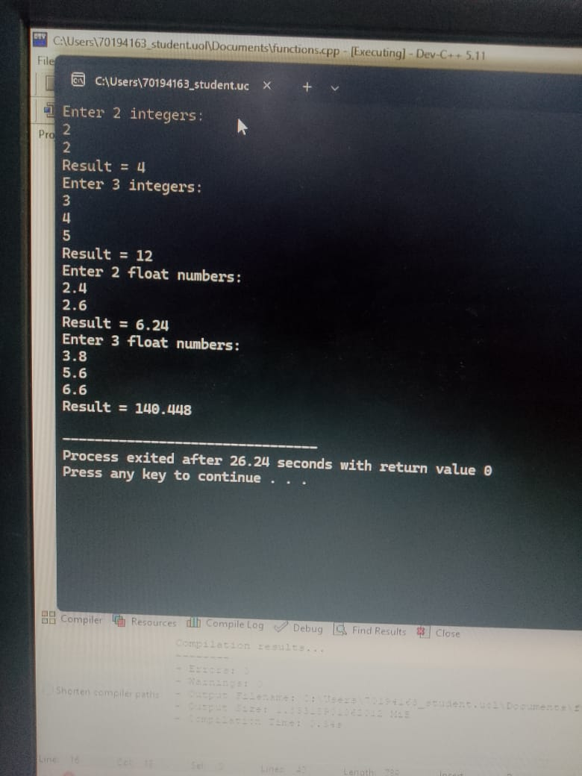

LAB 10
FLOWCHARTS
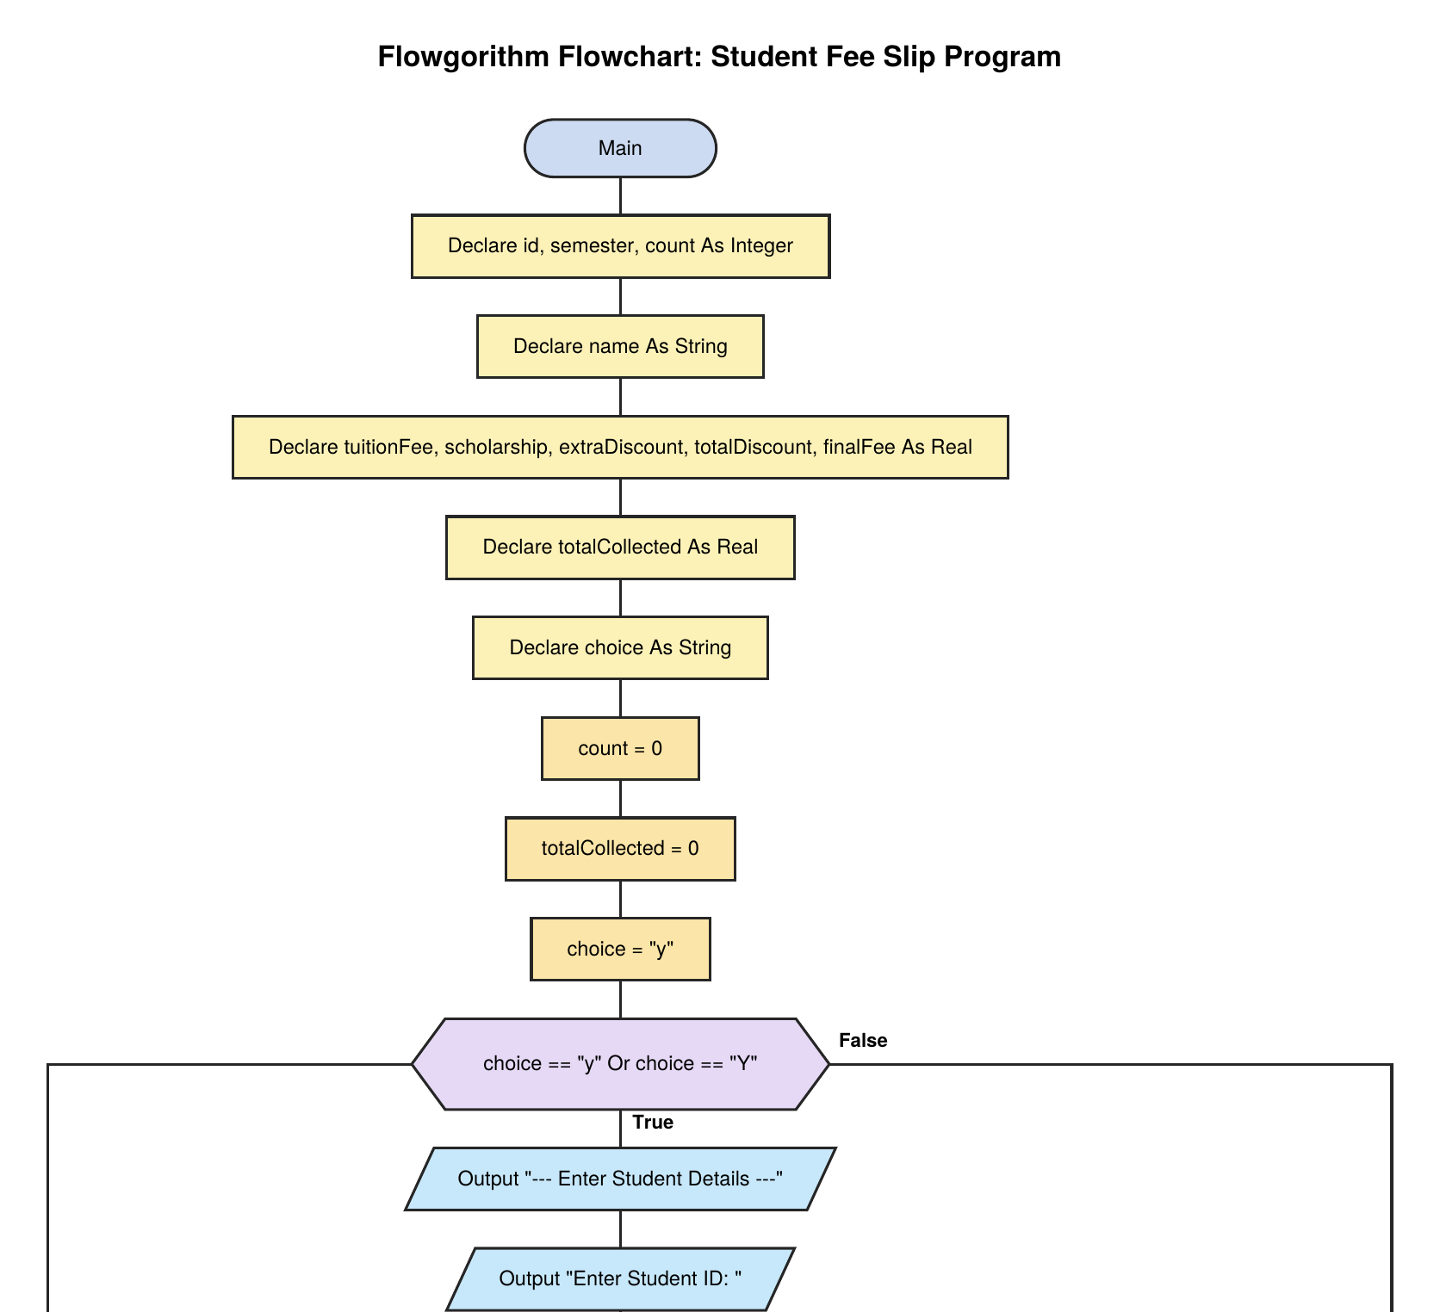

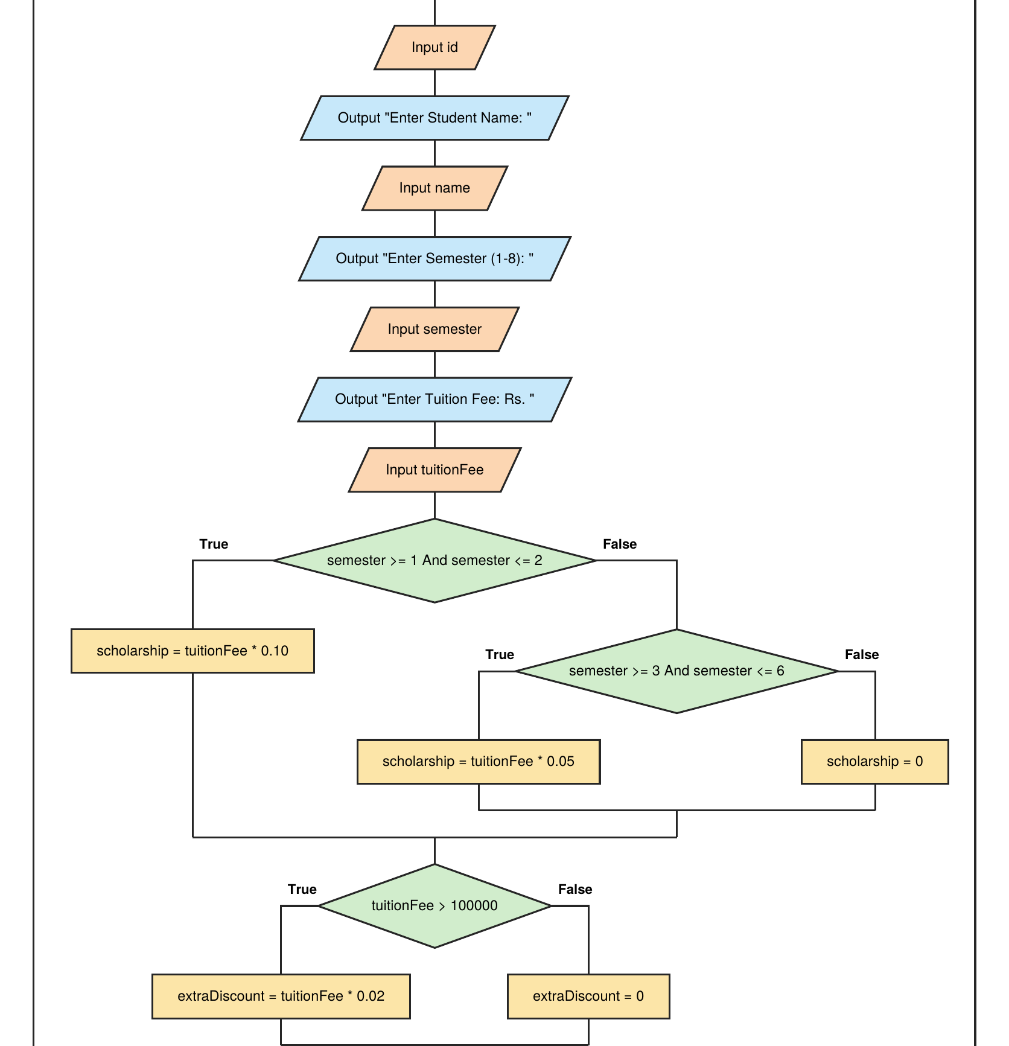

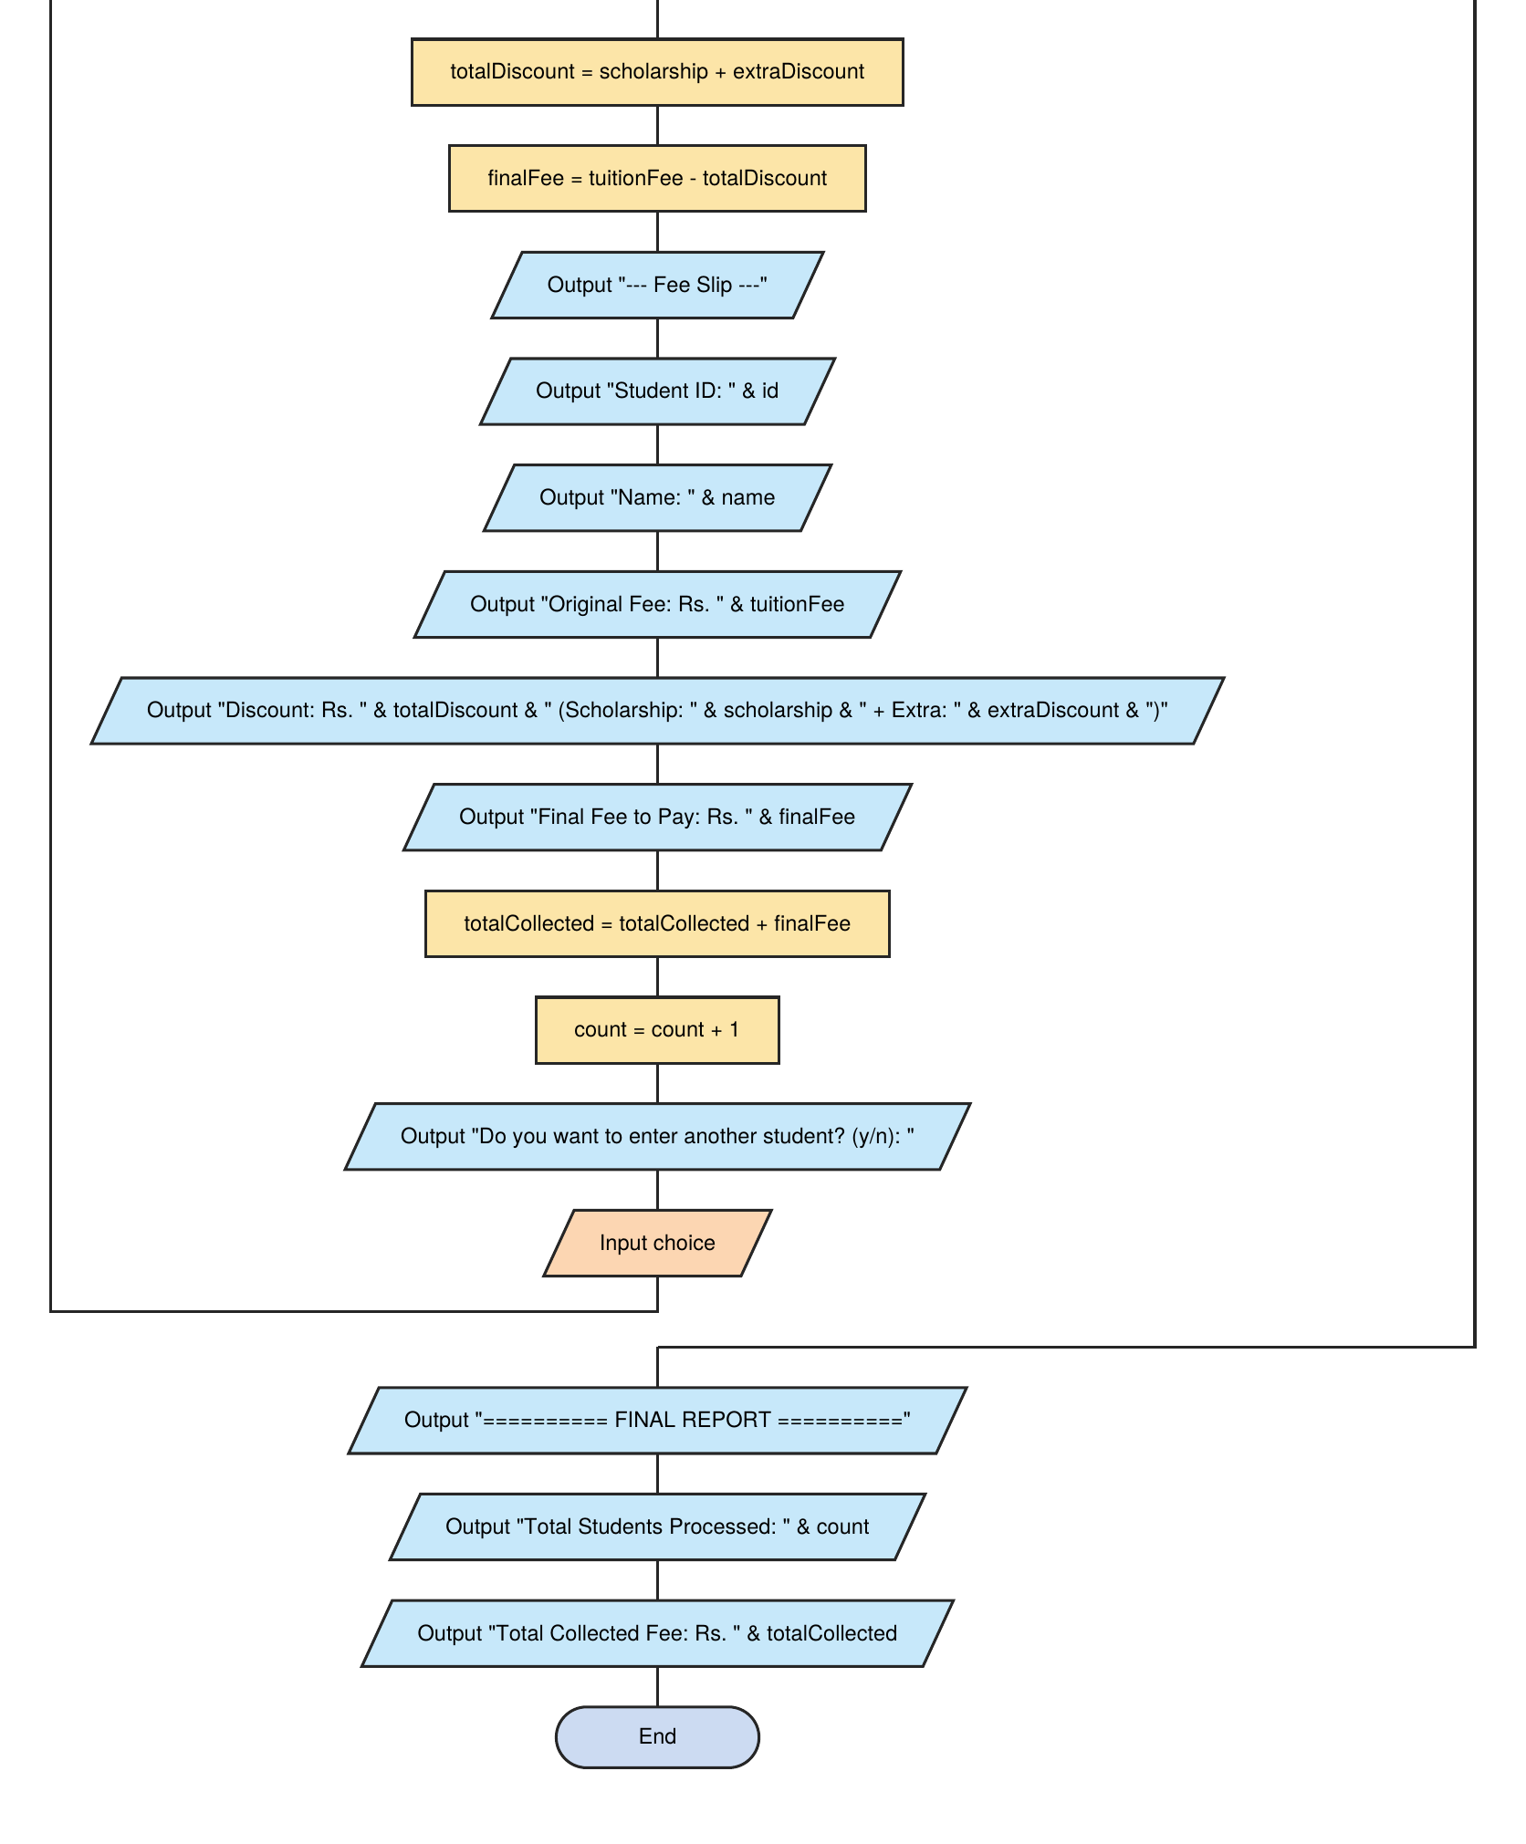

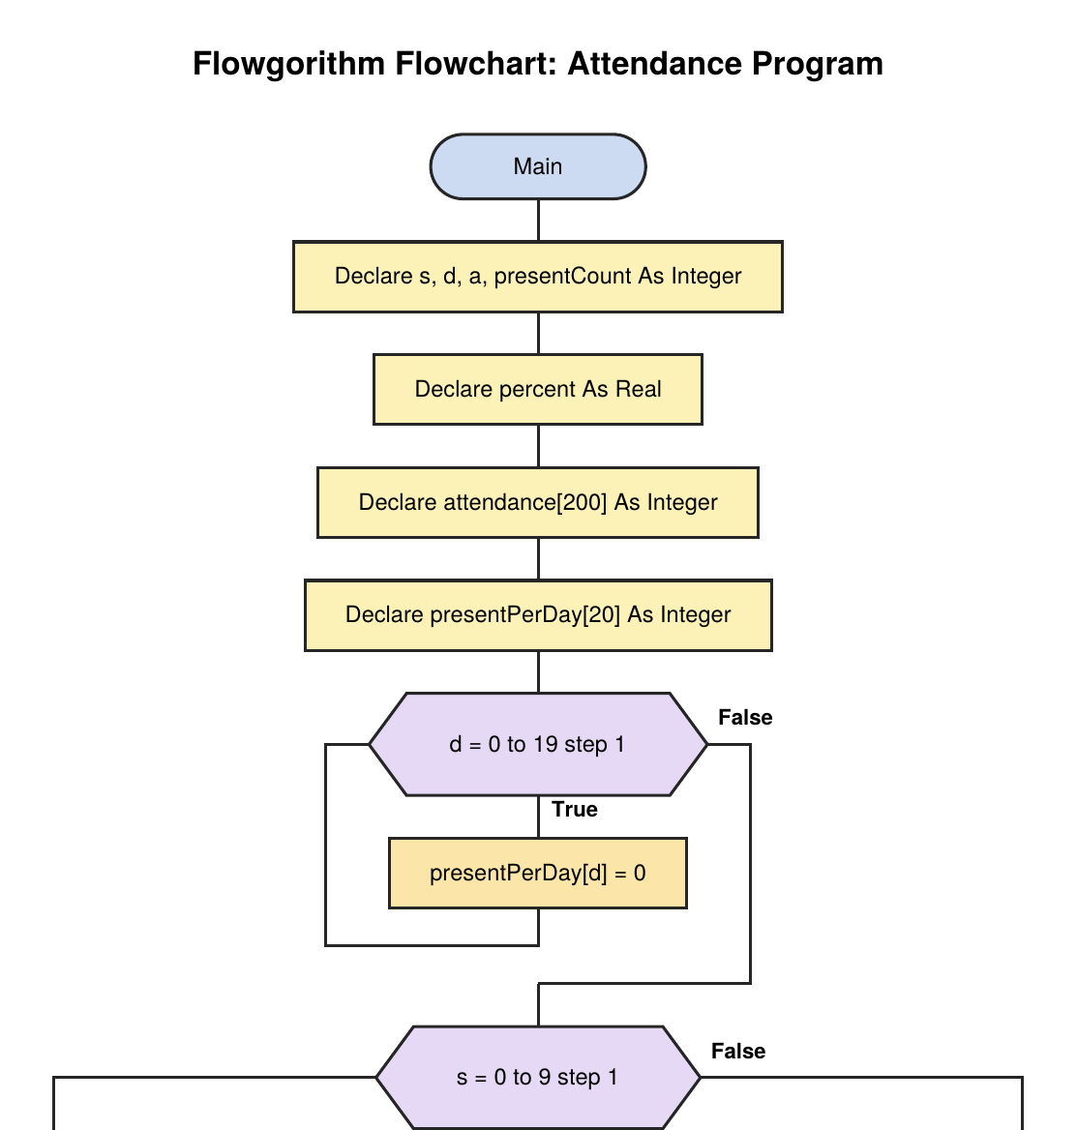

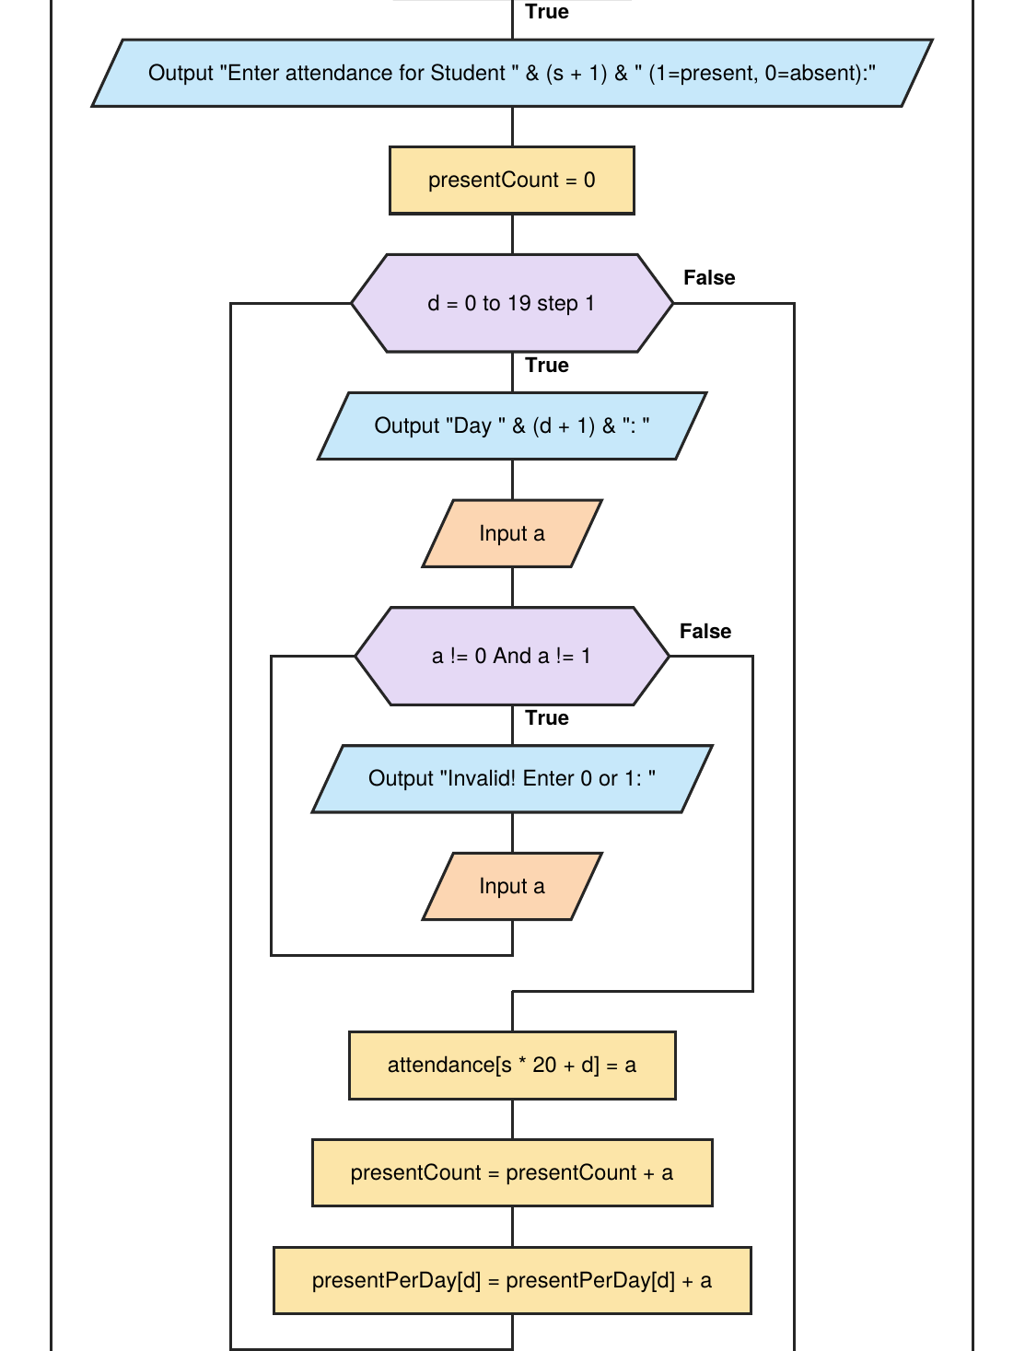

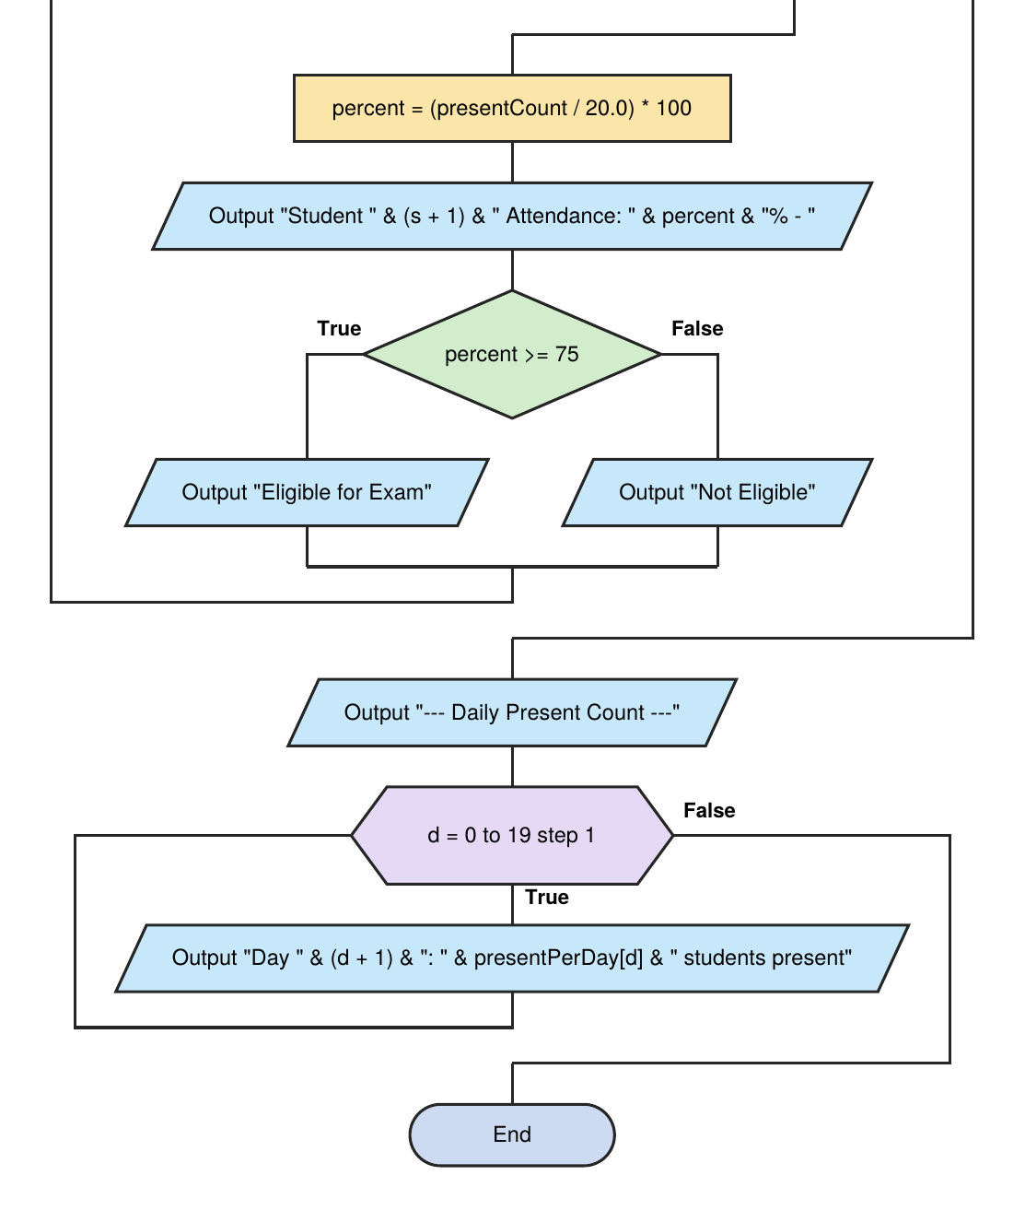

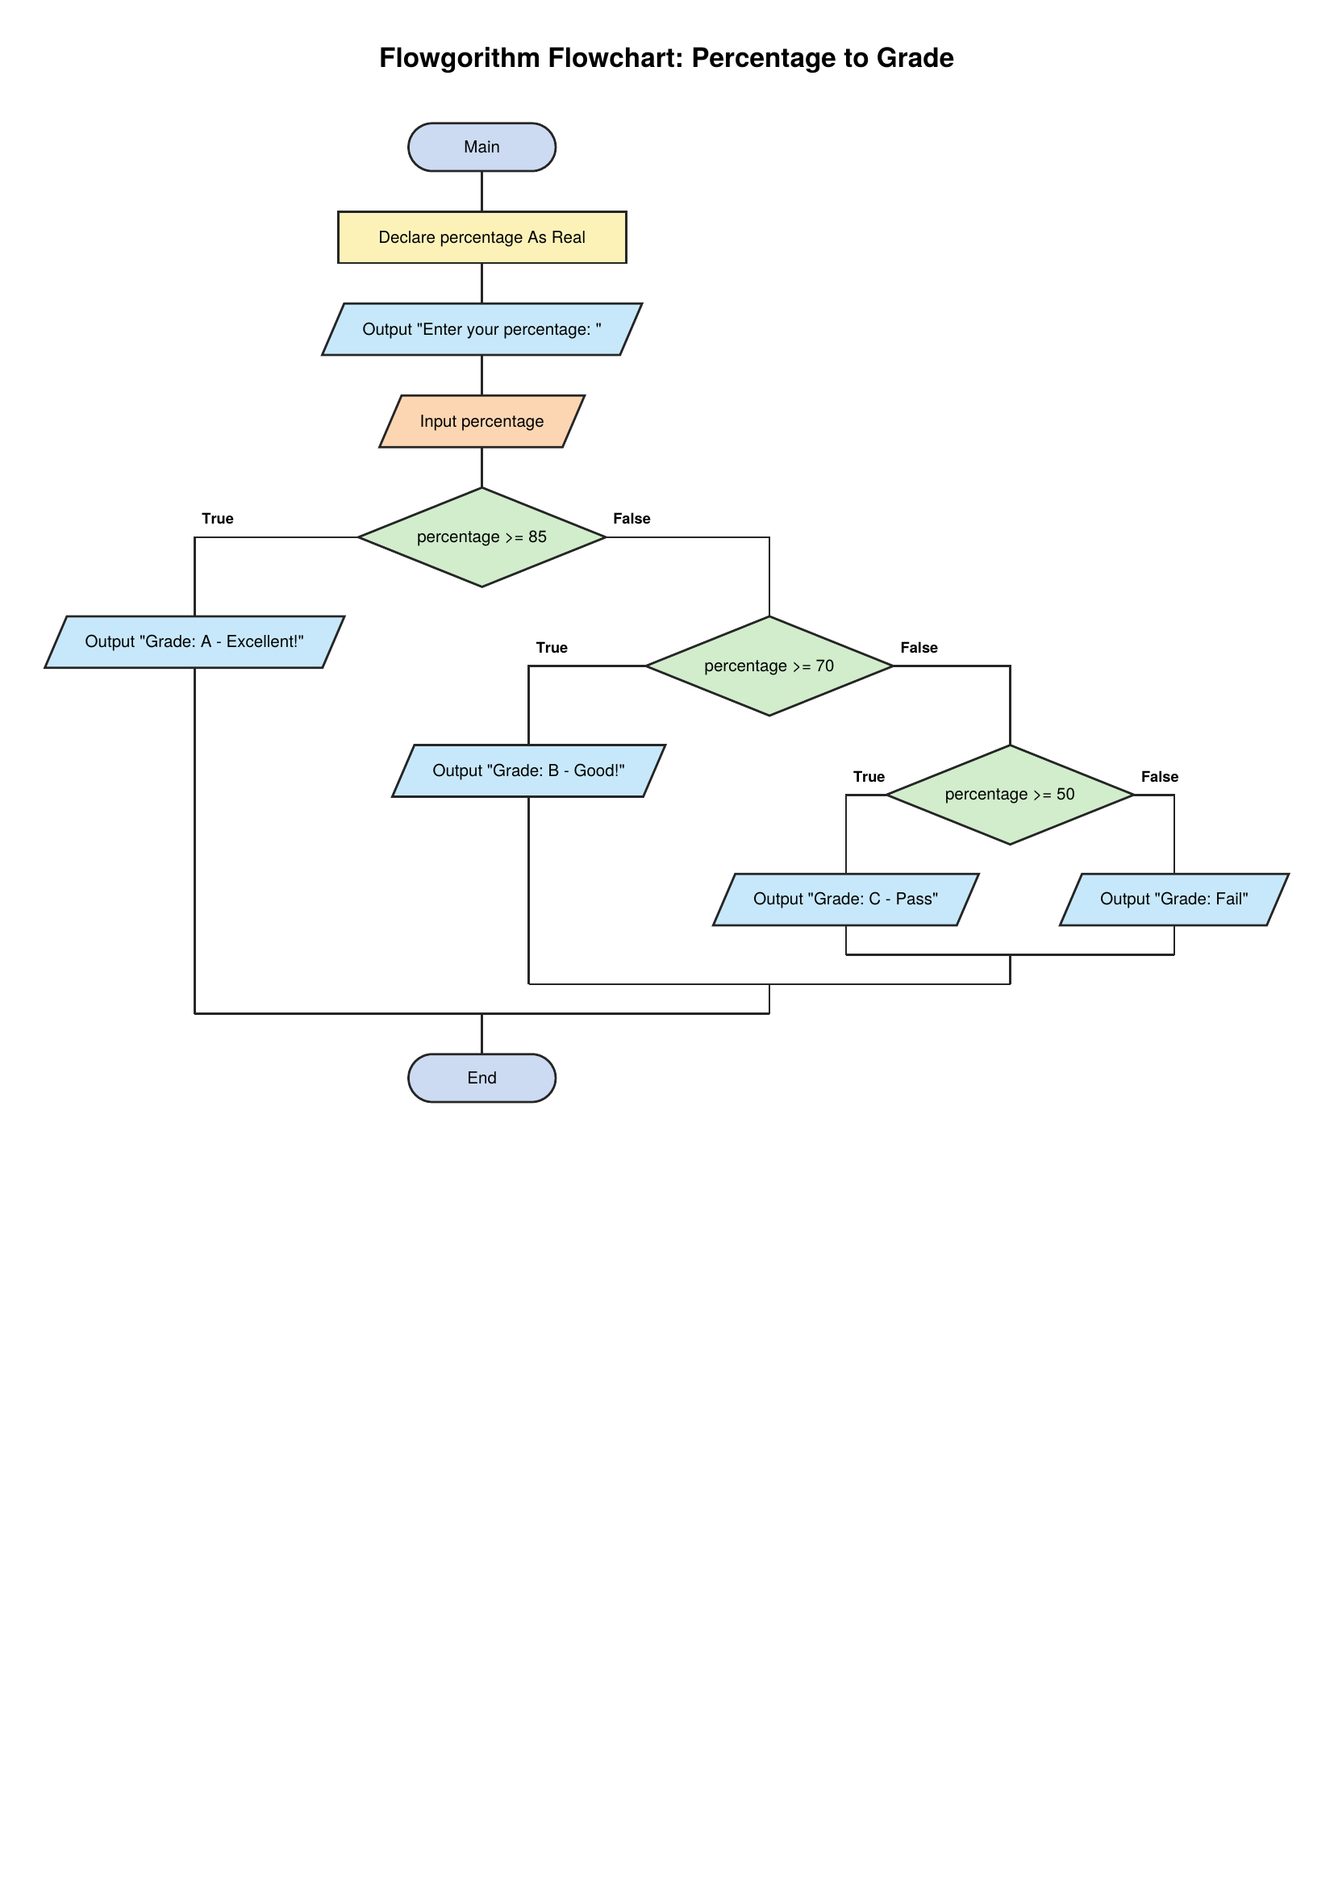

Submitted by: Aansa Mazhar
SAP ID : 70194163
Department: CS & IT department
Program: BS – Cyber Security
Section: 2A
Subject: Programming Fundamentals
Document: LAB manual
Submitted To: Prof. Danial Asif.

